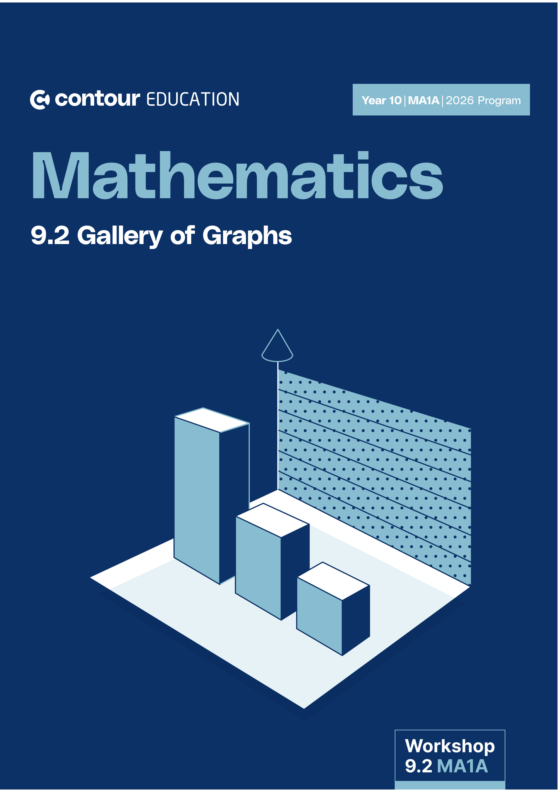


Website: contoureducation.com.au | Phone: 1800 888 300
Email: hello@contoureducation.com.au

VCE Mathematical Methods ¾
Topic Name [0.X]
Workshop Solutions


- Recap $+$ Warm Up (6 Marks)


Sub-Section: Cheat Sheet Recap

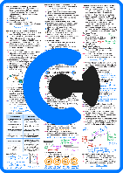
Cheat Sheet

  Order of Transformations  “Dr T”  - The Dr T (or $DRT$) order provides a consistent method for describing and performing transformations.  - To apply the Dr T Order, we follow these steps:  - Dilations: Apply any dilations (stretches or compressions).  - Reflections: Perform any reflections across an axis.  - Translation: Lastly, shift the graph horizontally and/or vertically.  Remember, Dr T!  - If we focus on the first quadrant curve:  decreases  - So, when $x$ increases, $y$ __________________.  increases  - And, when $x$ decreases, $y$ __________________.  inversely  - And, we say that $x$ and $y$ are __________________ proportional. | Asymptote  - Asymptotes are straight lines that the graph approaches but does not meet.  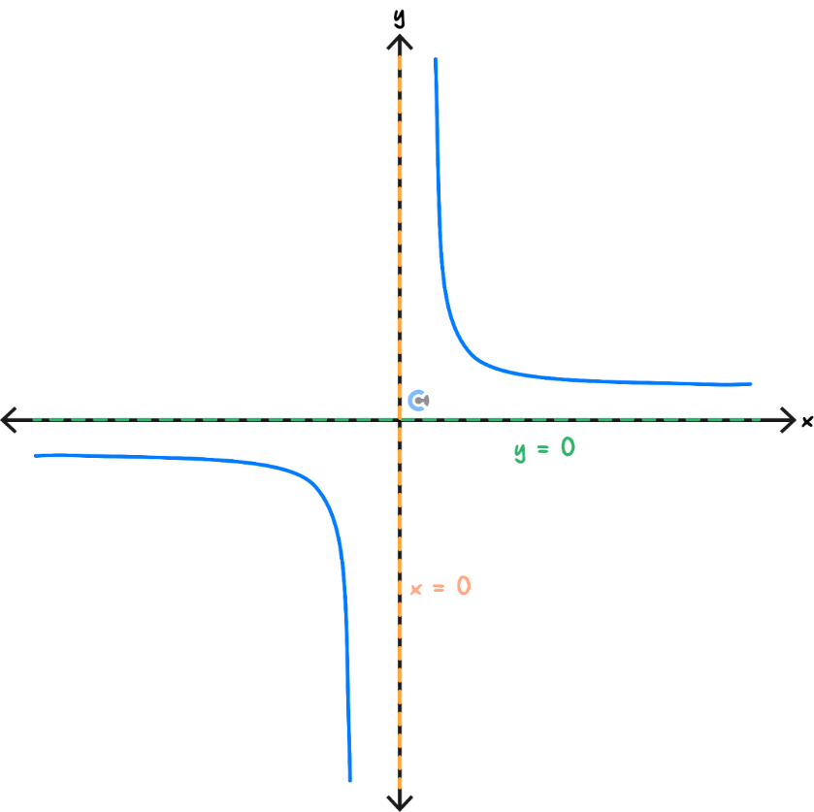  Rectangular Hyperbola  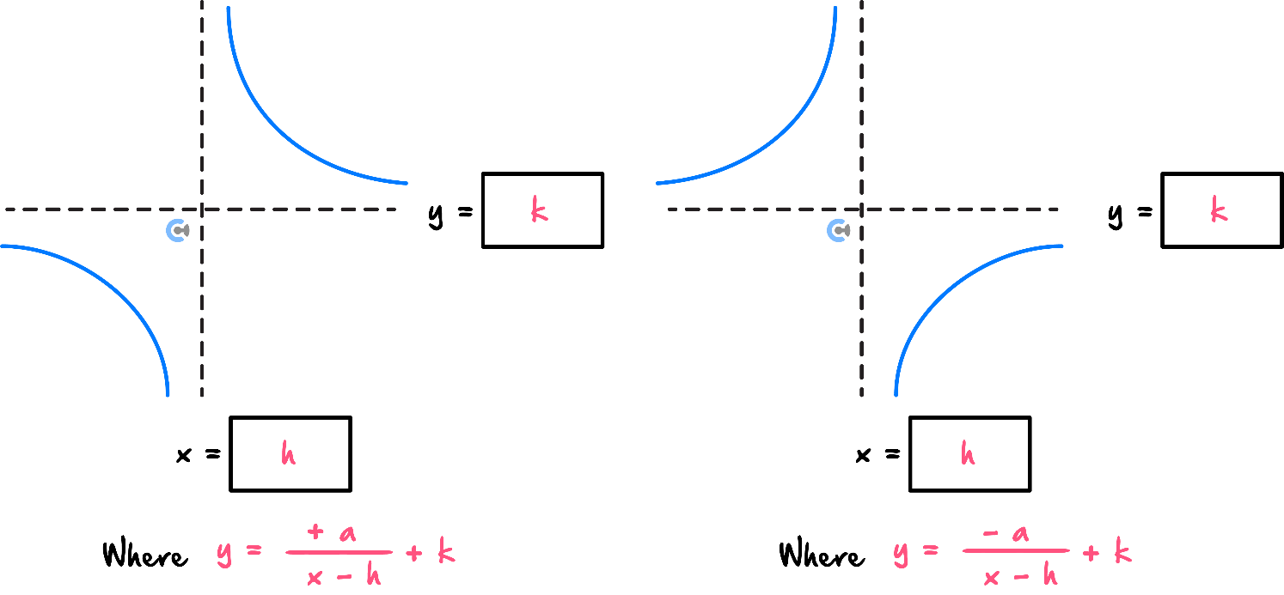  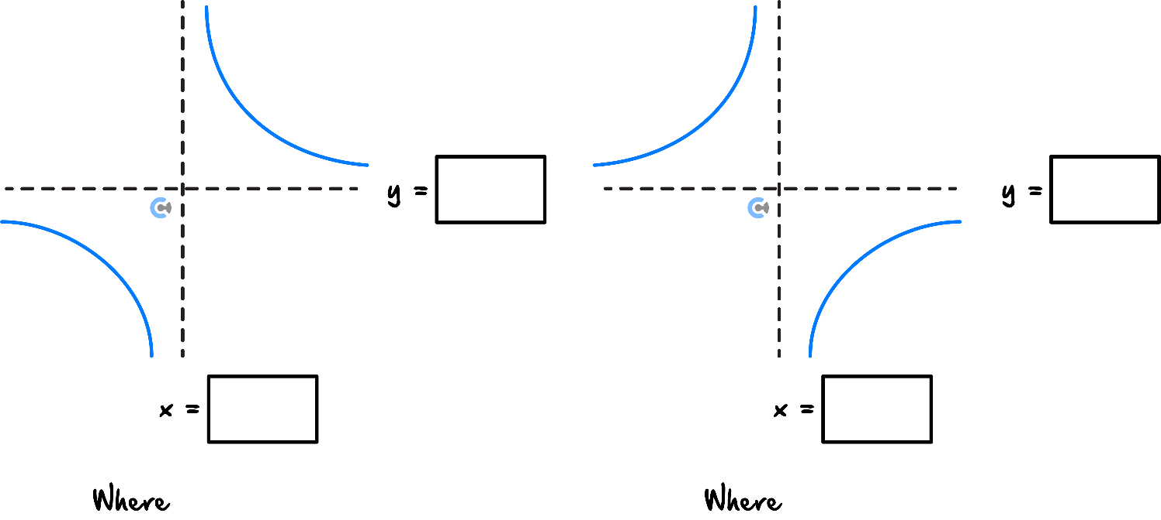

Cheat Sheet

Circles  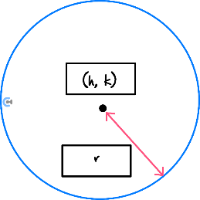  $${\left(x-h\right)}^{2}+{\left(y-k\right)}^{2}=r^{2}$$  $where, r>0$.  $$(h,k)$$  Centre: ________________  $$r$$  Radius: ________________  Graphing a Circle  - Step $1$: Find the centre of the circle.  - Step $2$: Find the radius of the circle.  - Step $3$: Find the axes intercepts (if they exist).  - Step $4$: Find the top/bottom of the circle by $±$ radius to centre $y$-value.  - Step $5$: Find the left/right of the circle by $±$ radius to the centre $x$-value.  - Step $6$: Identify the shape of the graph and sketch the curve.  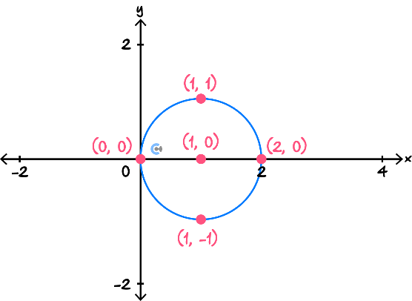 | Graphing a Circle    - There are three ways a line and a circle can be associated:  - Line intersects the circle.  - Line touches the circle.  - Line is outside the circle.  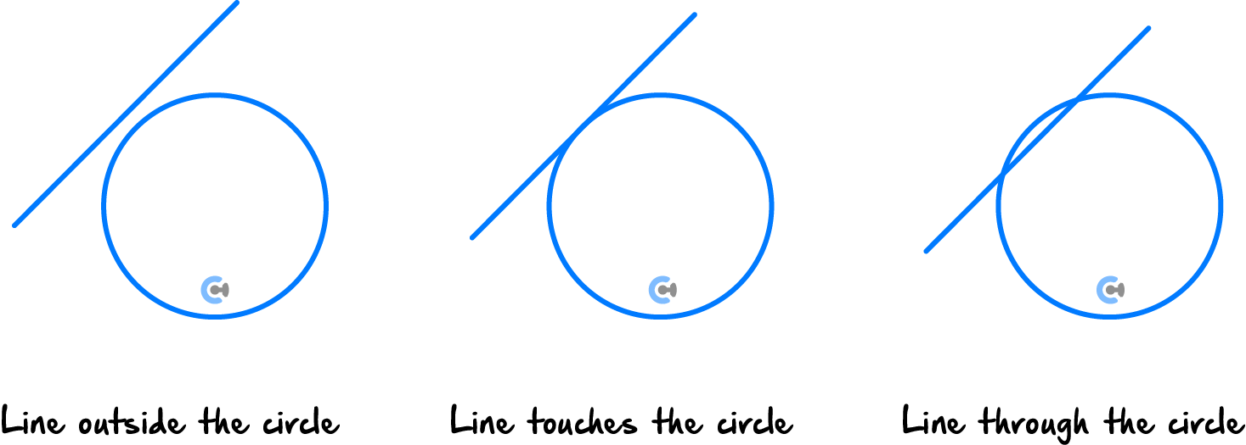  $$1$$  $$0$$  ___________Intersection ___________Intersection __________Intersection  $$2$$

Sub-Section: Warm Up


INSTRUCTION:

- Mastery: 6 Marks. 6 Minutes Writing.

- Extension: Skip

- (6 marks)

Answer the following questions:

  - For the function $y=2\sqrt{x+5}-2$, state the transformations that have occurred. (1 mark)

Solution:
The graph has been dilated by a factor of $2$ from the $x$-axis, translated $5$ units to the left (a translation of $5$ units in the negative $x$-direction) and translated $2$ units down (a translation of $2$ units in the negative $y$ direction).

  - For the function $y=-\sqrt{x-3},$ state whether the graph is reflected in the $x$-axis or $y$-axis. (1 mark)
Solution:
The negative sign is outside the square root.
Therefore, the graph is reflected in the $x$-axis.

  - For the hyperbola $y=\frac{6}{x - 2}+1$, state its vertical and horizontal asymptotes. (1 mark)

Solution:
Vertical asymptote:
$$x-2=0$$
$$x=2$$
Horizontal asymptote:
$$y=1$$

  - A circle has equation ${\left(x-4\right)}^{2}+{\left(y+3\right)}^{2}=25$.

State its centre and radius. (1 mark)

Solution:
Centre $= \left(4, -3\right)$
Radius $= \sqrt{25}= 5$

  - Find the$x$-intercepts of the circle: (1 mark)

$$x^{2}+y^{2}=36$$

Solution:
On the$x$-axis,$y = 0.$
$$x^{2}= 36$$
$$x = ±6$$
The $x$-intercepts are $\left(-6, 0\right)$ and $\left(6, 0\right).$

  - A straight line and a circle are being compared by substituting the line equation into the circle equation. The resulting quadratic has discriminant $0.$ How many points of intersection are there? (1 mark)

Solution:
A discriminant of $0$ gives one point of intersection.
The line is tangent to the circle.

- Exam $1$ Tech-Free (43 Marks)

Sub-Section: Ramping Up

INSTRUCTION:

- Mastery: 10 Marks. 13 Minutes Writing.

- Extension: 10 Marks. 10 Minutes Writing.

- (2 marks)

Consider the hyperbola:

$$y=\frac{1}{x-2}+1$$

  - State the transformations that have occurred to change this graph from $y=\frac{1}{x}$. (1 mark)

Solution:
Translations of $2$ units to the right, and $1$ unit up.

  - State the domain of the graph. (1 mark)

Solution:
$$x - 2≠ 0$$
$$x ≠ 2$$
Domain $= R/\{2\}$ or ($-$infinity, $2$) $∪$ ($2$, infinity)

- (2 marks)

Consider the hyperbola:
$$y=\frac{5}{x+3}-2$$

  - State the vertical asymptote. (1 mark)

Solution:
$$x + 3 = 0$$
Vertical asymptote: $x = -3$

  - State the horizontal asymptote. (1 mark)

Solution:
Horizontal asymptote: $y = -2$

- (2 marks)

A circular fountain is represented by
$$x^{2}+ y^{2}= 49$$

  - State the centre of the circle. (1 mark)

Solution:
Centre $= \left(0, 0\right)$

  - Sketch the graph of the circle on a pair of coordinate axes, labelling all four axes intercepts. (1 mark)
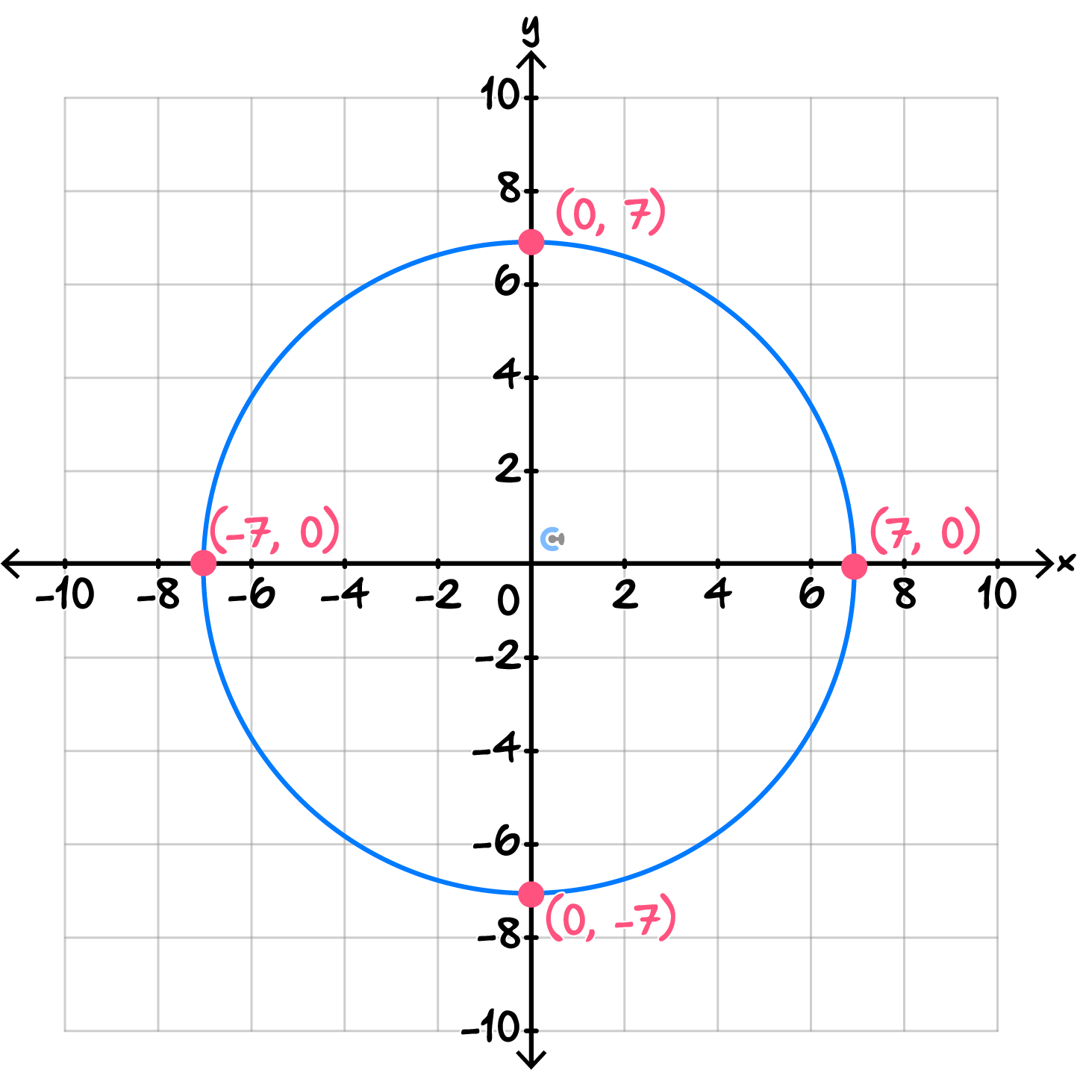
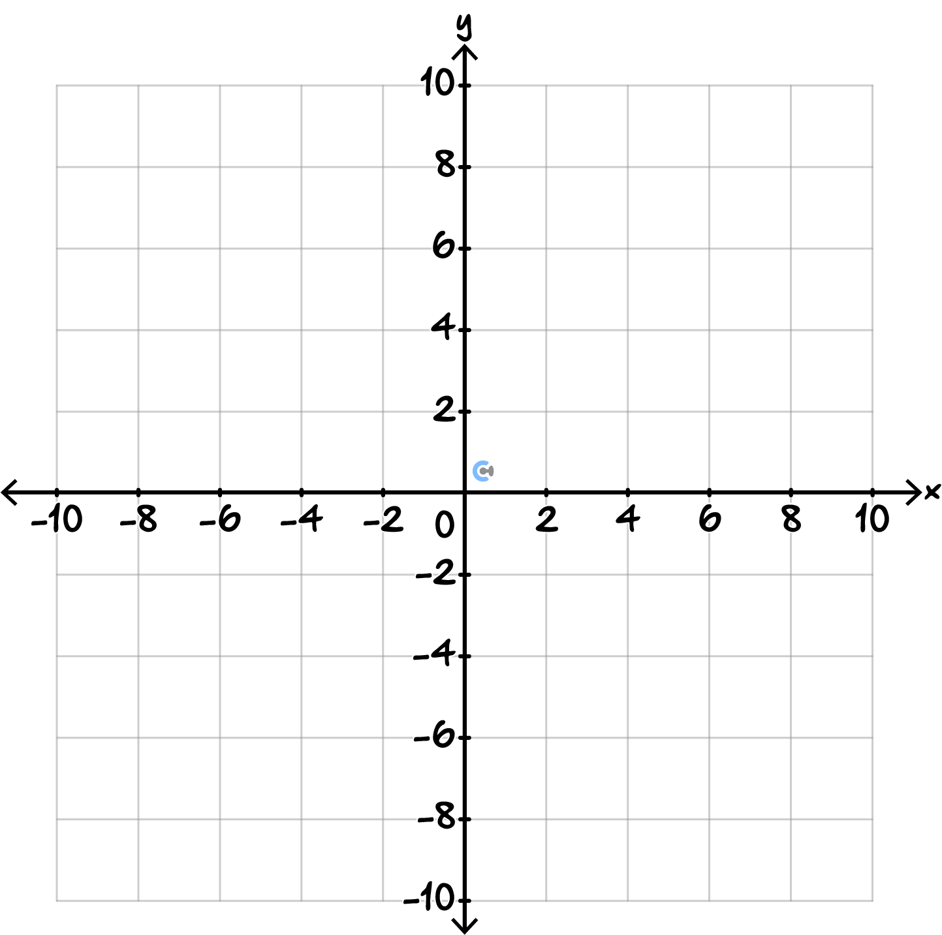

- (4 marks)

A circular garden is represented by:
$${\left(x-2\right)}^{2}+{\left(y+1\right)}^{2}=16$$

  - State the centre and radius of the circle. (2 marks)

Solution:
Centre $= \left(2, -1\right)$
Radius $= \sqrt{16}= 4$
b.

  - A straight pathway is represented by:
$$y=x-1$$Determine whether the pathway intersects the circle at two points, one point, or no points. (2 marks)

Solution:
Substitute $y = x - 1$into the circle:
$${\left(x - 2\right)}^{2}+ {\left(x - 1 + 1\right)}^{2}= 16$$
$${\left(x - 2\right)}^{2}+ x^{2}= 16$$
$$x^{2}- 4x + 4 + x^{2}= 16$$
$$x^{2}- 2x - 6 = 0$$
Discriminant:
$$D = {\left(-2\right)}^{2}- 4\left(1\right)\left(-6\right)= 28$$
Since $D > 0$, the pathway intersects the circle at two points.

Sub-Section: Getting Trickier

INSTRUCTION:

- Mastery: 15 Marks. 20 Minutes Writing.

- Extension: 15 Marks. 15 Minutes Writing.

- (4 marks)

Consider the function $y=\frac{3}{x-4}+2$.

  - Determine the $x$-intercept of the graph. (1 mark)

Solution:
Set $y = 0:$
$$0=\frac{3}{x-4}+2$$
$$-2=\frac{3}{x-4}$$
$$-2(x-4)=3$$
$$x - 4 =\frac{-3}{2}$$
$$x =\frac{5}{2}$$
$x$-intercept $= \left(\frac{5}{2}, 0\right)$

  - State the domain and range of the function. (1 mark)

Solution:
For the domain:
$$x - 4 ≠ 0$$
$$x ≠ 4$$
Domain $= R/\{4\}$
For the range:
$$y ≠ 2$$
Range $= R/\{2\}$

  - Sketch the graph, clearly showing its endpoint, $x$-intercept and direction of curvature. (2 marks)

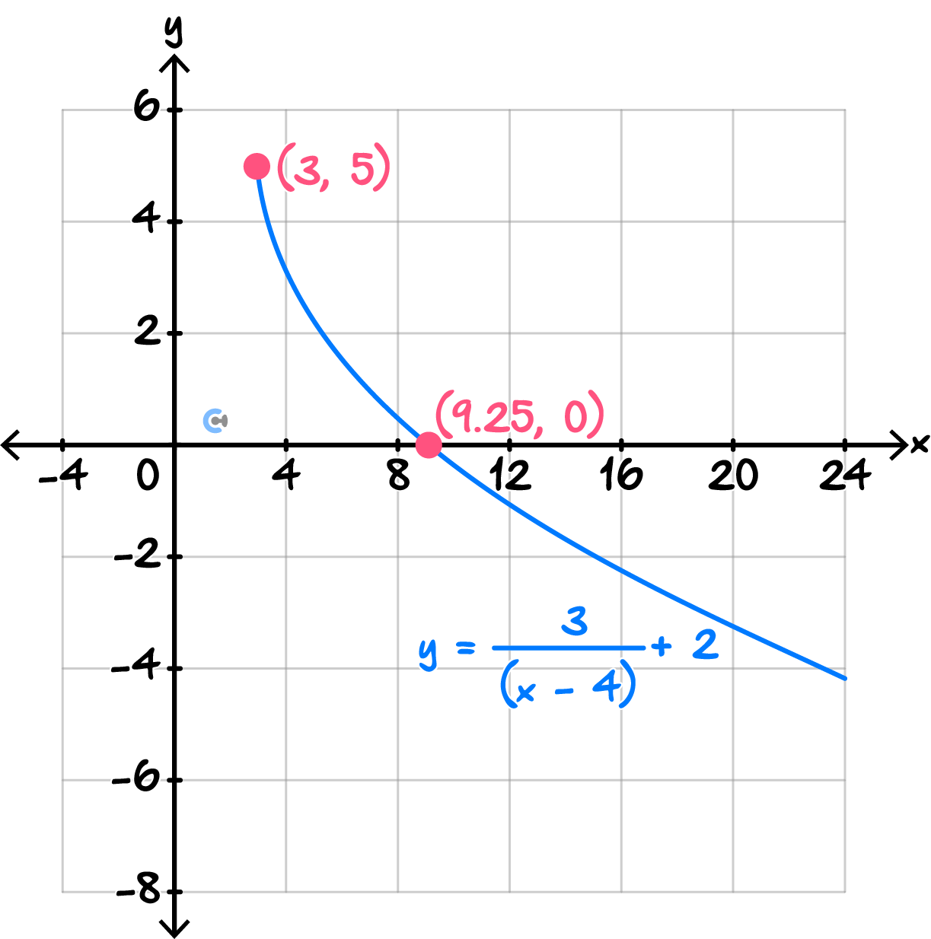
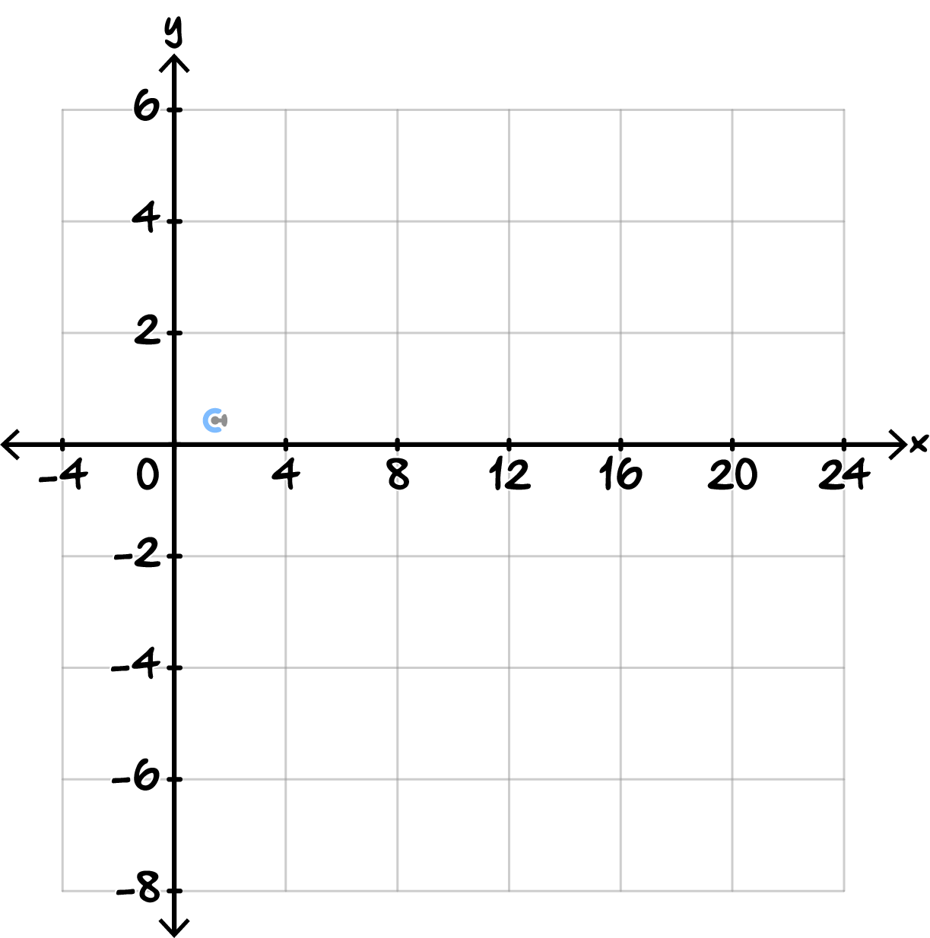

- (3 marks)

Consider the hyperbola:
$$y=-\frac{8}{x-2}+3$$

  - State the equations of the asymptotes. (1 mark)

Solution:
Vertical asymptote:
$$x - 2 = 0$$
So, $x = 2$.
Horizontal asymptote:
$$y = 3$$

  - Find the $x$-intercept and $y$-intercept. (2 marks)

Solution:
For the$x$-intercept, set $y = 0:$
$$0 = -\frac{8}{x - 2}+ 3$$
$$3 =\frac{8}{x - 2}$$
$$3\left(x - 2\right)= 8$$
$$3x - 6 = 8$$
$$3x = 14$$
$$x =\frac{14}{3}$$
$x$-intercept $= \left(\frac{14}{3}, 0\right)$
For the $y$-intercept, set$x = 0:$
$$y = -\frac{8}{-2}+ 3$$
$$y = 4 + 3$$
$$y = 7$$
$y$-intercept $= \left(0, 7\right)$

- (4 marks)

A circular garden is represented by:

$$x^{2}+y^{2}-6x+4y-12=0$$

  - Rewrite the equation in the form ${\left(x-h\right)}^{2}+{\left(y-k\right)}^{2}=r^{2}$. (1 mark)
$$\left(x^{2}- 6x\right)+ \left(y^{2}+ 4y\right)= 12$$
$$\left(x^{2}- 6x + 9\right)+ \left(y^{2}+ 4y + 4\right)= 12 + 9 + 4$$
Therefore:
$${\left(x - 3\right)}^{2}+ {\left(y + 2\right)}^{2}= 25$$

  - State the centre and radius of the circle. (1 mark)

Solution:
Centre $= \left(3, -2\right)$
Radius $= \sqrt{25}= 5$

  - Sketch the circle, showing the centre and axes intercepts. (2 marks)

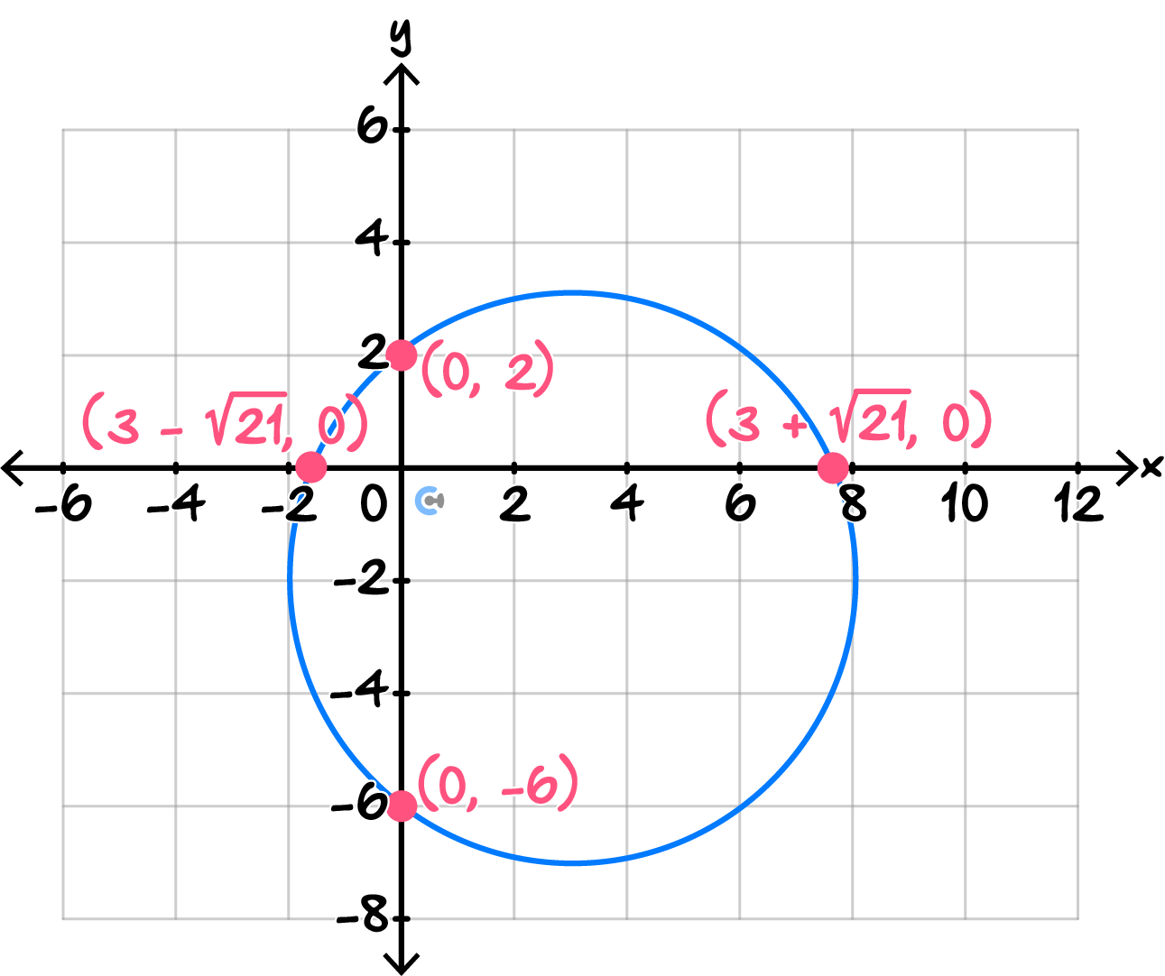
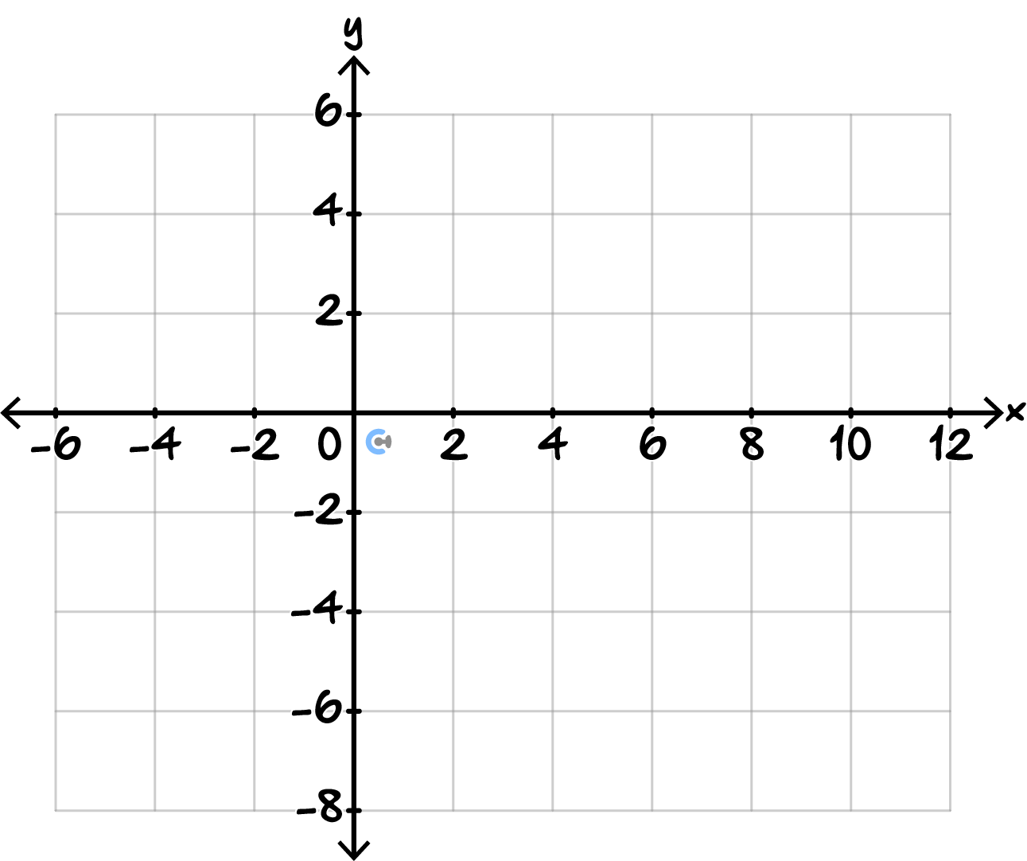

- (4 marks)

A circular pond is modelled by:

$$x^{2}+y^{2}=34$$

A straight walking path is modelled by:

$$y=x-2$$

  - Find the coordinates of the two points where the path intersects the pond. (2 marks)
Solution:
Substitute $y = x - 2$into the circle:
$$x^{2}+ {\left(x - 2\right)}^{2}= 34$$
$$x^{2}+ x^{2}- 4x + 4 = 34$$
$$2x^{2}- 4x - 30 = 0$$
Divide by $2$:
$$x^{2}- 2x - 15 = 0$$
Factorise:
$$\left(x - 5\right)\left(x + 3\right)= 0$$
So:
$x = 5$or$x = -3$

When $x = 5:$
$$y = 5 - 2 = 3$$
Point $= \left(5, 3\right)$
When $x = -3:$
$$y = -3 - 2 = -5$$
Point $= \left(-3, -5\right)$

  - Sketch the circle and the line and label the two intersection points on your sketch. (2 marks)
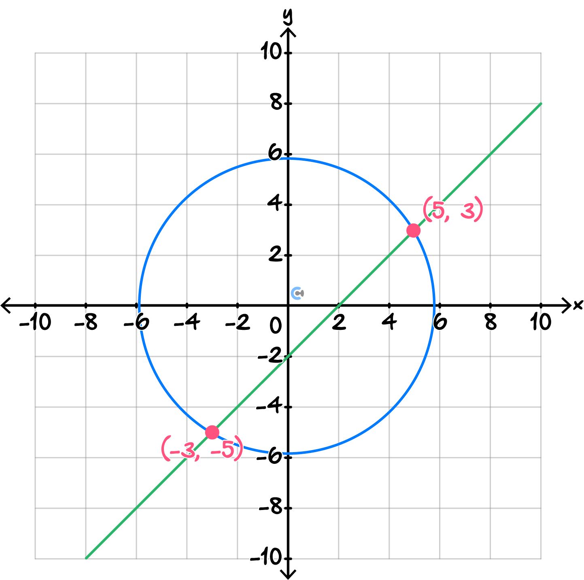
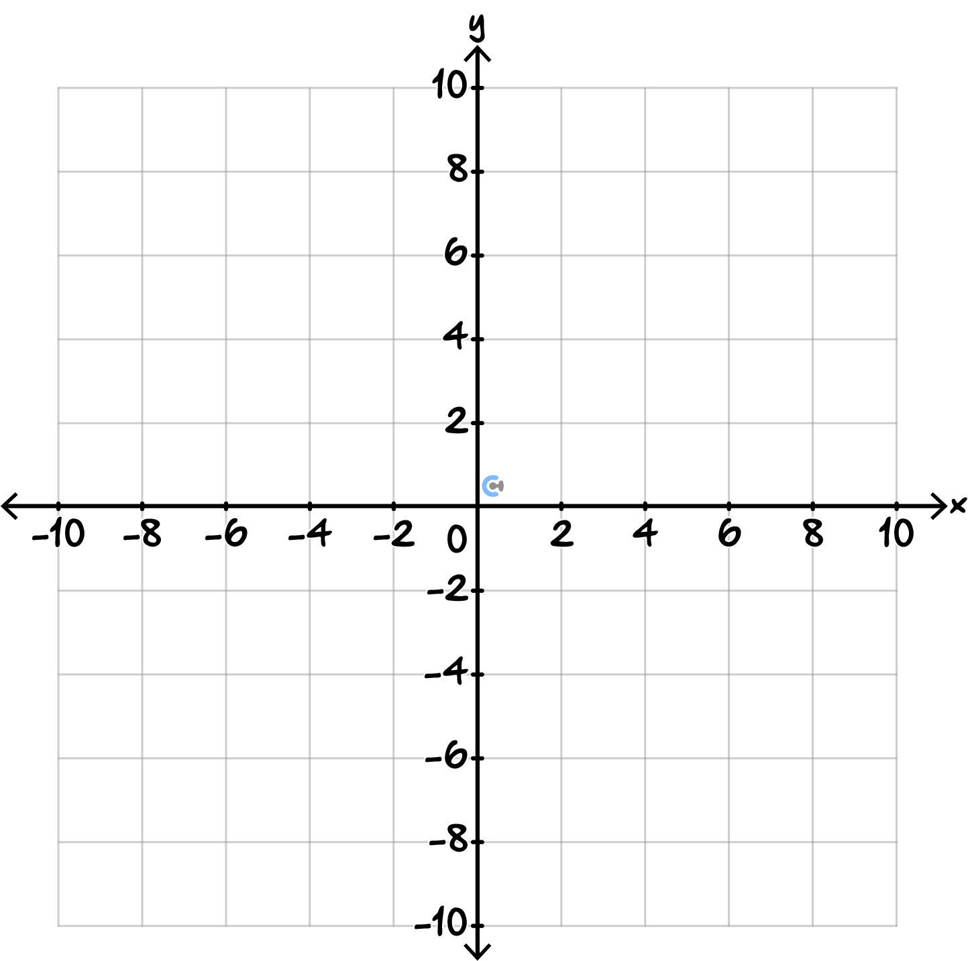

Sub-Section: Extension

INSTRUCTION:

- Mastery: Skip.

- Extension: 18 Marks. 23 Minutes Writing.

- (8 marks)

A hyperbola has the form:
$$y=\frac{a}{x-h}+k$$

The graph has asymptotes:

$x=3$and$y=-2$

The graph also passes through the point $(5, 4)$.

  - Determine the values of $h$ and $k$. (1 mark)

Solution:
Since the graph has asymptotes of $x = 3$ and $y = -2$,
$h = 3$ and $k = -2$

  - Find the value of $a$, and hence, write the equation of the hyperbola. (2 marks)

Solution:
Substitute $(5, 4)$:
$$4=\frac{a}{5-3}-2$$
$$6=\frac{a}{2}$$
$$a=12$$
$$y=\frac{12}{x-3}-2$$

  - Find the $x$- and$y$-intercepts. (2 marks)

For $y$-intercept:
$$y=\frac{12}{0-3}-2$$
$$y=-4-2$$
$$y=-6$$
For $x$-intercept:
$$0=\frac{12}{x-3}-2$$
$$2=\frac{12}{x-3}$$
$$2\left(x-3\right)=12$$
$$x-3=6$$
$$x=9$$

  - Sketch the hyperbola, labelling any asymptotes and intercepts present. (3 marks)
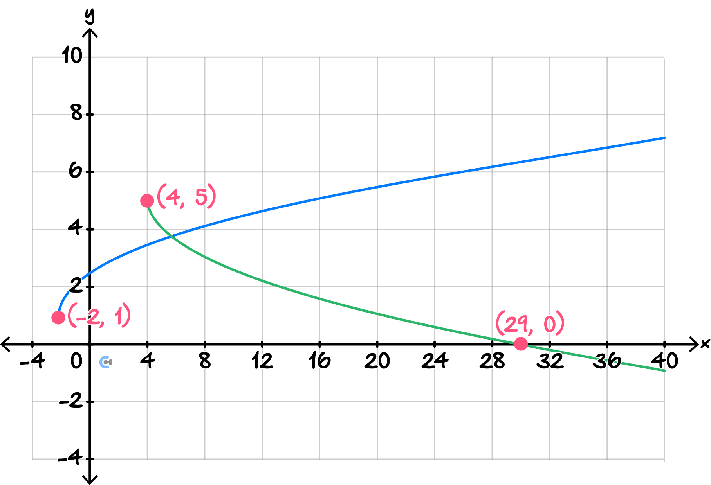
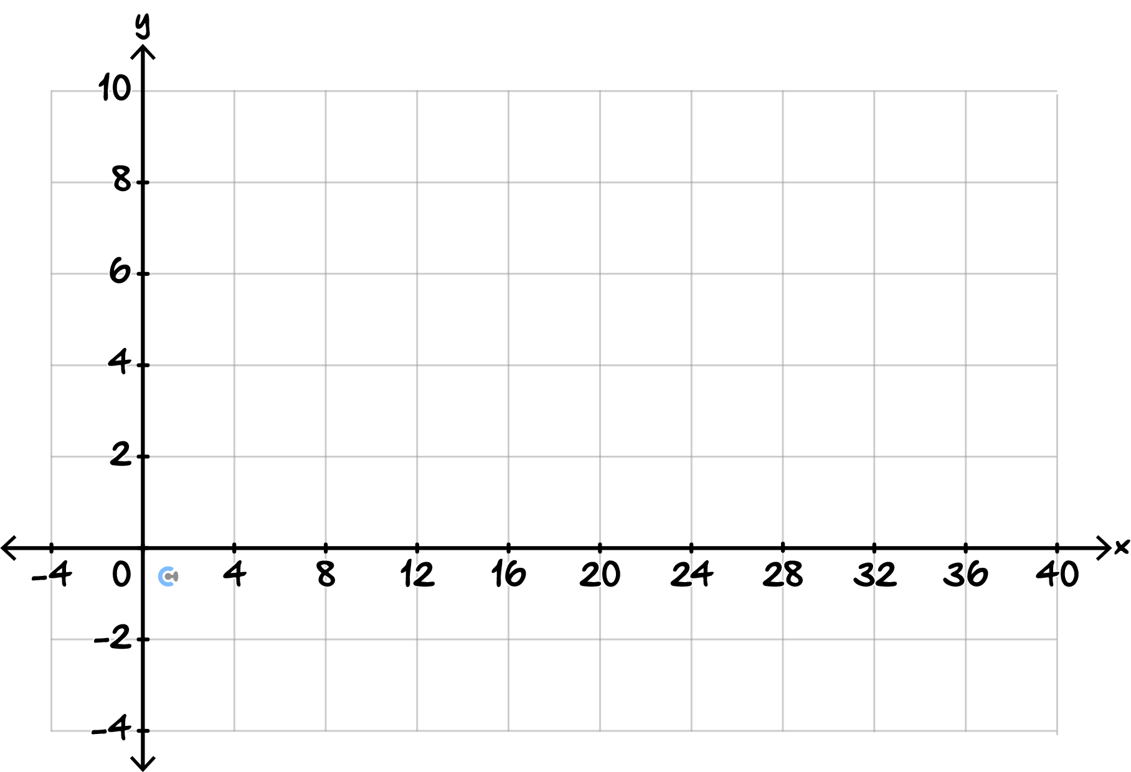

- (5 marks)

A water tank has a sensor whose readings are modelled by:

$$y=\frac{6}{x}$$

After the tank is repositioned, the sensor model becomes:

$$y=-\frac{6}{x-3}+2$$

  - State the equations of the asymptotes of the new model. (1 mark)
Solution:
Vertical asymptote:
$$x - 3 = 0$$
So, $x = 3$
Horizontal asymptote:
$$y = 2$$

  - Describe the transformations from $y=\frac{6}{x}$ to the new model. (2 marks)

Solution:
- Reflection in the $x$-axis.
- Translation$3$units to the right.
- Translation$2$units up.

  - Sketch both hyperbolas on the same axes, clearly showing the asymptotes of each graph and the orientation of their branches. (2 marks)

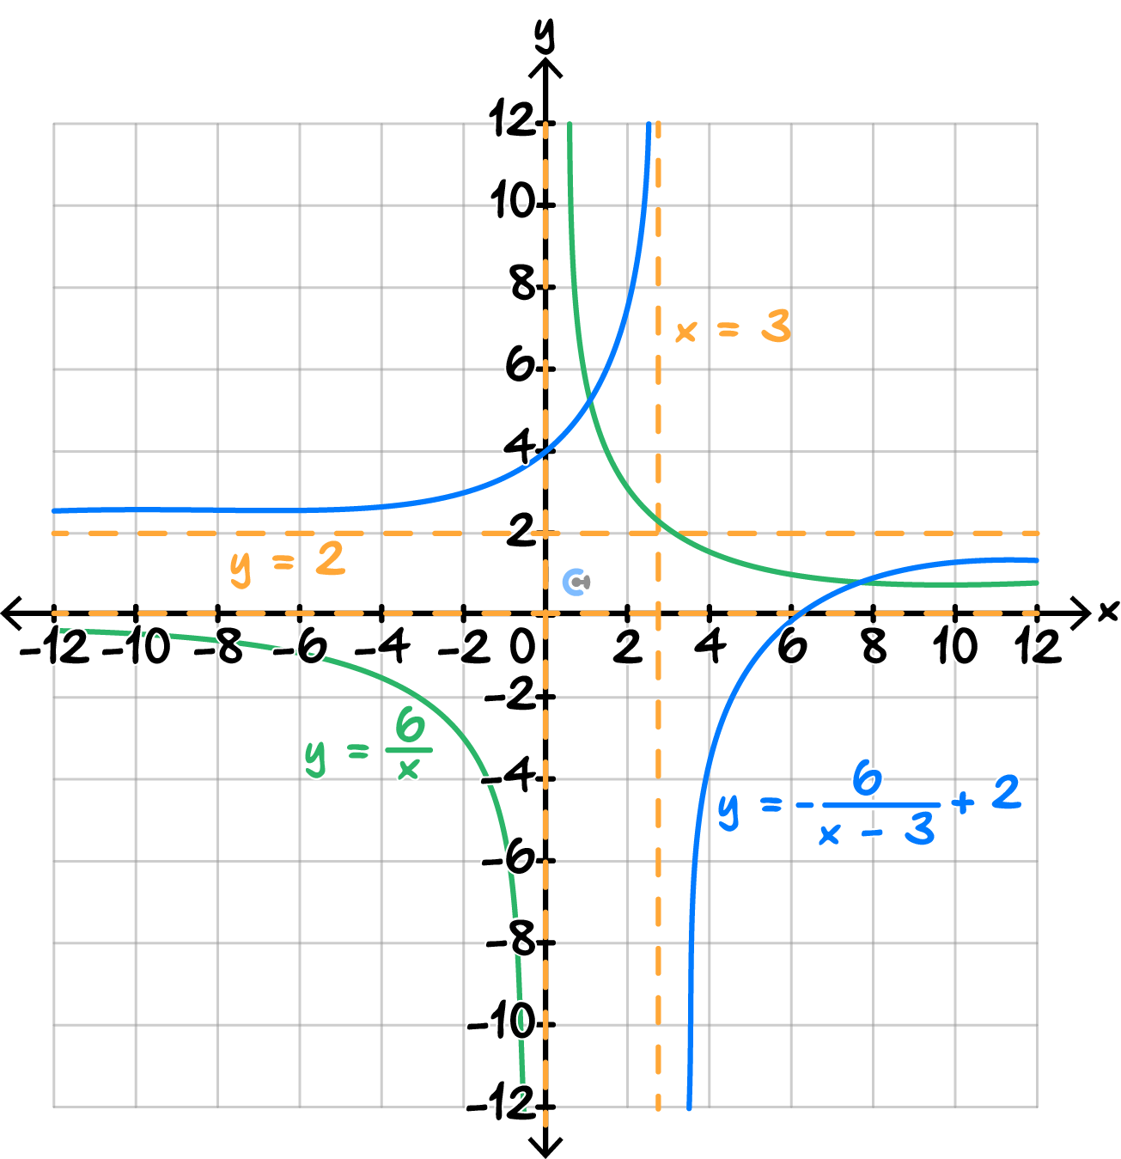
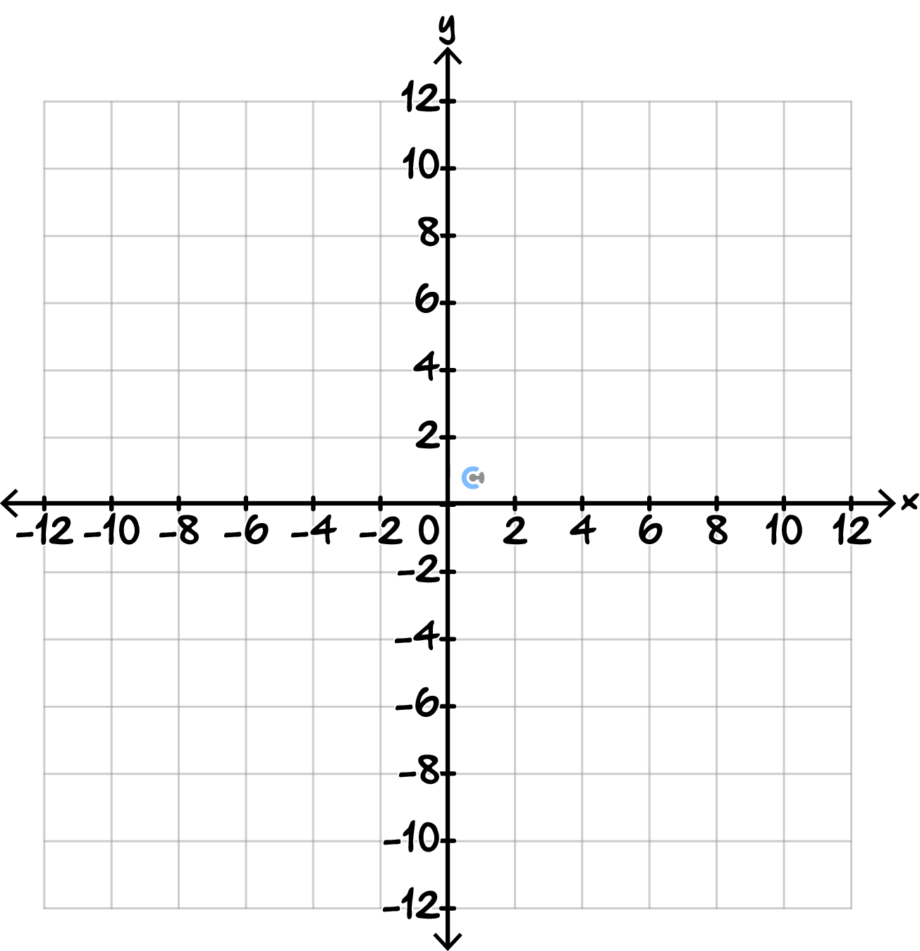

- (5 marks)

A circular exclusion zone around a construction site is modelled by:

$${\left(x-2\right)}^{2}+{\left(y+1\right)}^{2}=25$$

A proposed access road is represented by:

$$y=mx+4$$

where $m$ is the gradient of the road.

  - Explain what condition must be satisfied for the road to touch the circular zone at exactly one point. (1 mark)
Solution:
When the road touches the circle at exactly one point, the resulting quadratic has exactly one real solution.
Therefore, the discriminant must equal $0.$

  - Determine the exact values of $m$ for which the road is tangent to the circular zone. (2 marks)
$$D = 0$$
$${\left(10m - 4\right)}^{2}- 4\left(m^{2}+ 1\right)\left(4\right)= 0$$
$$100m^{2}- 80m + 16 - 16m^{2}- 16 = 0$$
$$84m^{2}- 80m = 0$$
$$4m\left(21m - 20\right)= 0$$
Therefore:
$m = 0$or $m =\frac{20}{21}$
Solution:
Substitute $y = mx + 4$into the circle:
$${\left(x - 2\right)}^{2}+ {\left(mx + 5\right)}^{2}= 25$$
Expand:
$$x^{2}- 4x + 4 + m^{2x^{2}}+ 10mx + 25 = 25$$
$$\left(m^{2}+ 1\right)x^{2}+ \left(10m - 4\right)x + 4 = 0$$
For tangency:

  - The engineer wants the road to pass through the construction site's centre rather than touch the boundary. What gradient $m$ would make this possible? (2 marks)
Solution:
The centre of the circle is $\left(2, -1\right).$
For the line $y = mx + 4$to pass through the centre:
$$-1 = 2m + 4$$
$$2m = -5$$
$$m = -\frac{5}{2}$$
So, the required gradient is $-\frac{5}{2}.$


Let’s take a BREAK!

- $CAS$ Recap

INSTRUCTION:

- Mastery: 2 Marks. 2 Minutes Writing.

- Extension: 2 Marks. 2 Minutes Writing.


Calculator Commands

- $TI$-$N$spire  - Click ‘Graph’ in the Menu page.  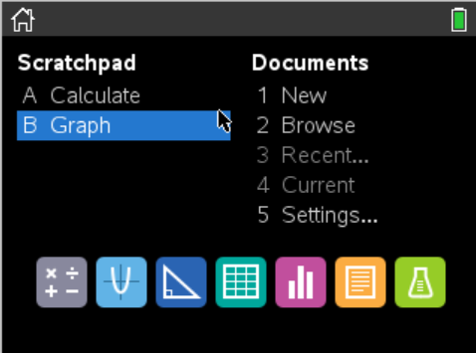  - Enter the function.  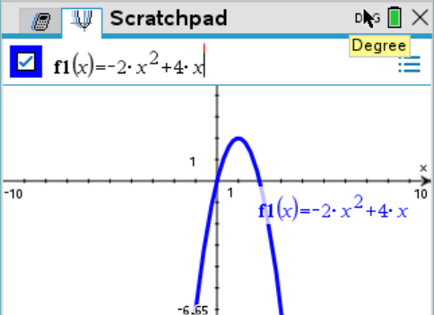 | - Casio Classpad  - Menu  - Main    - Math $3$  - Define  - EXE  - Click the icon.    - Drag and drop the equation into the graphing window.  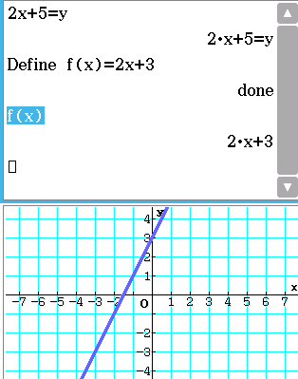  - Click on the graphing window.  - Up top, click on zoom.  - Click auto.  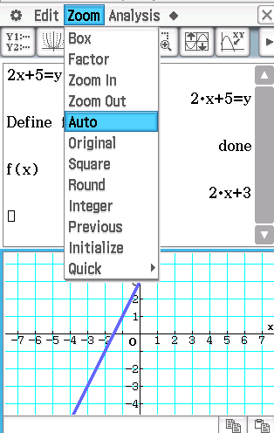 | - Mathematica  - Use the Plot function.  - MUST specify the domain in the form  {$x$, $xmin xmax$}.  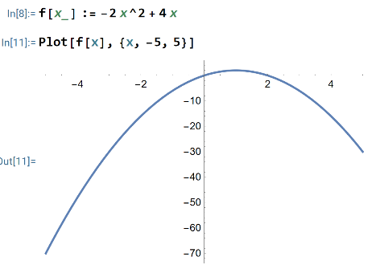

- (2 marks)

Sketch the graph of $y=\frac{11}{x-14}-6$. Label both asymptotes and the axes intercepts.

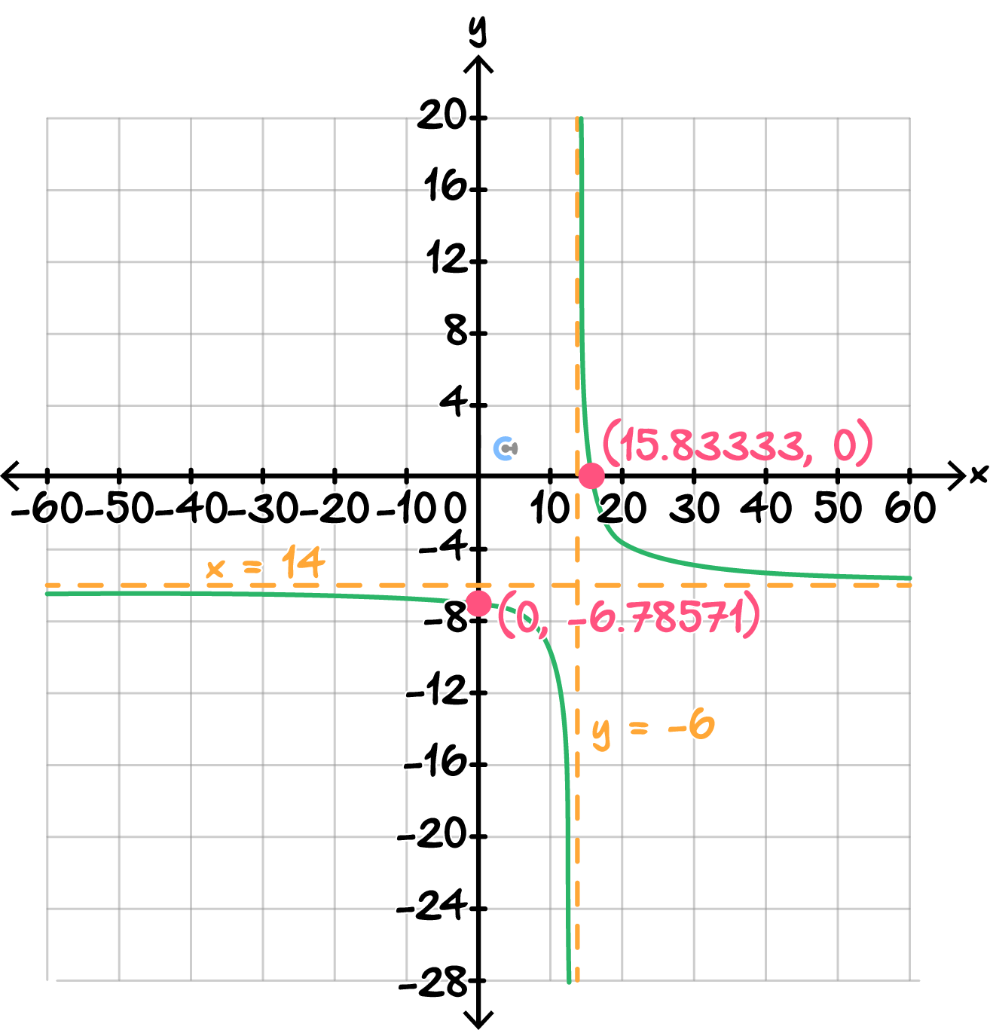
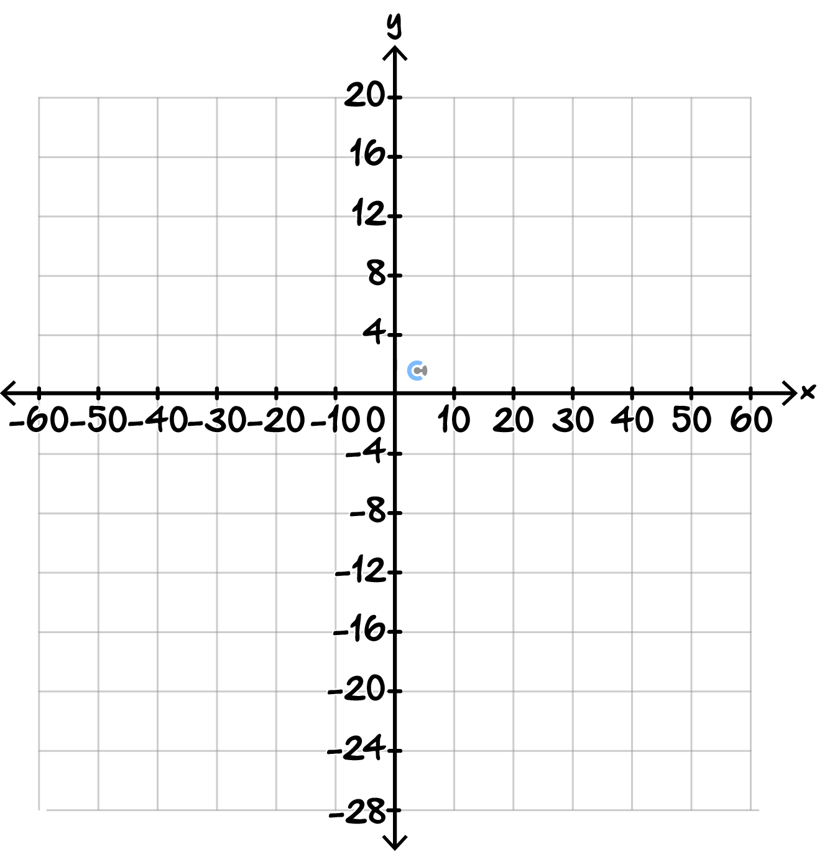

- Exam $2$ Tech-Active (41 Marks)

Sub-Section: Getting Serious

INSTRUCTION:

- Mastery: 13 Marks. 20 Minutes Writing.

- Extension: 13 Marks. 13 Minutes Writing.

- (3 marks)

Consider the function:
$$y=-1.5\sqrt{x-2}+4$$

  - Determine the $x$-intercept, giving your answer correct to two decimal places. (1 mark)
Solution:
Set $y = 0:$
$$0 = -1.5\sqrt{x - 2}+ 4$$
$$1.5\sqrt{x - 2}= 4$$
$$\sqrt{x - 2}=\frac{4}{1.5}$$
$$x - 2 = {\left(\frac{4}{1.5}\right)}^{2}$$
$$x = 9.11$$
$x$-intercept $= \left(9.11, 0\right)$

  - State the endpoint and range of the function. (1 mark)

Solution:
Endpoint $= \left(2, 4\right)$
Since $-1.5\sqrt{x - 2}≤ 0,$
$$y ≤ 4$$
Range $= \left(-∞, 4\right]$

  - Sketch the graph, showing the endpoint and $x$-intercept. (1 mark)

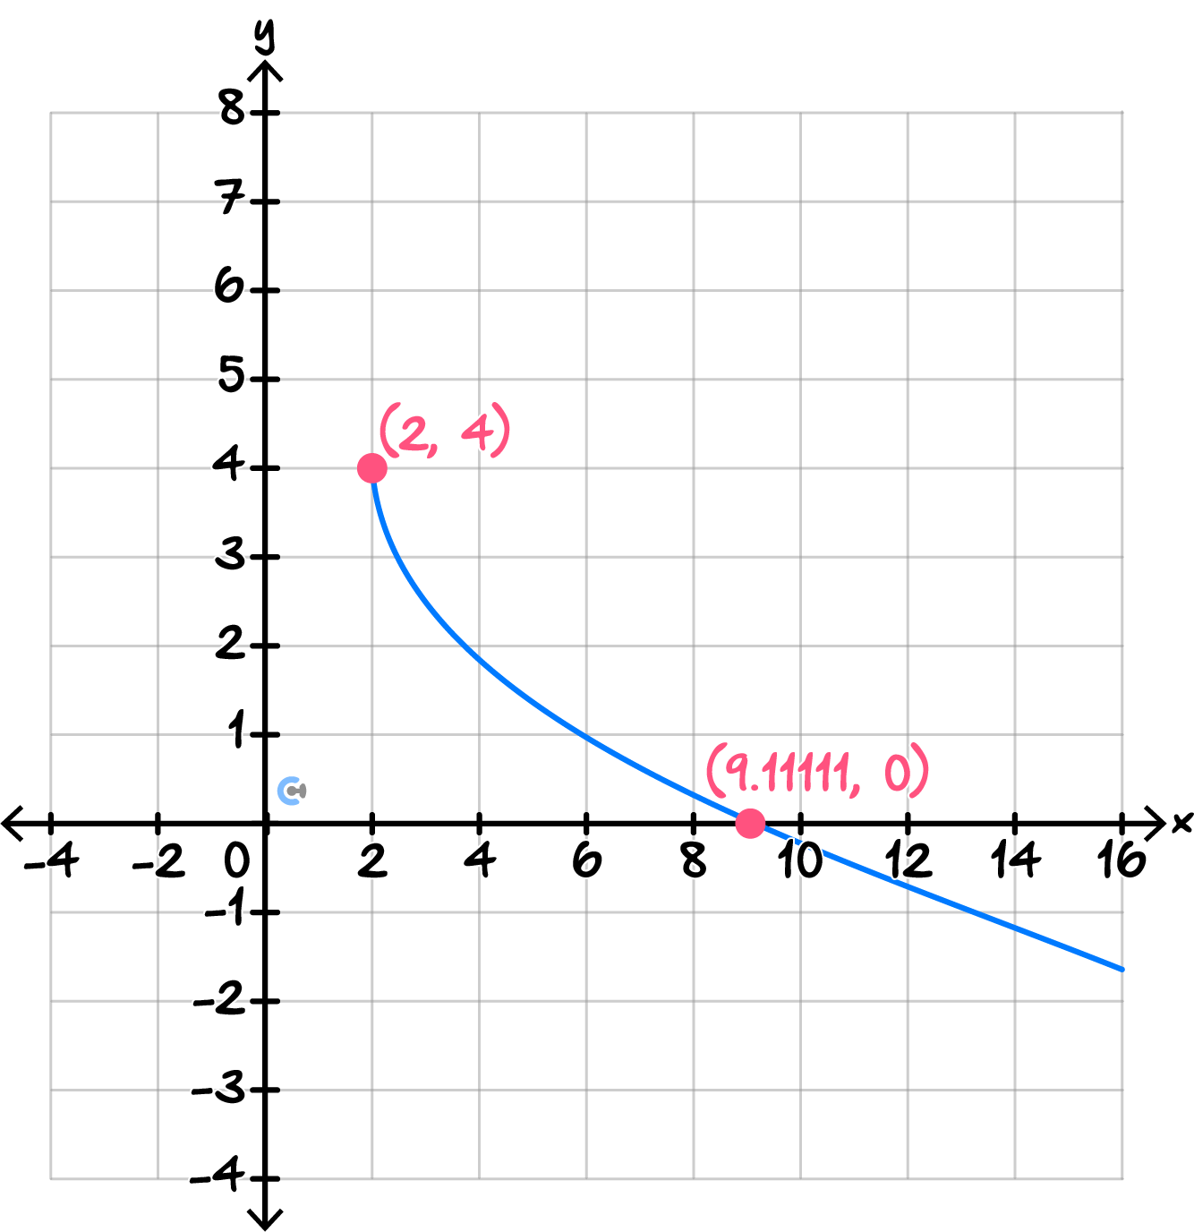
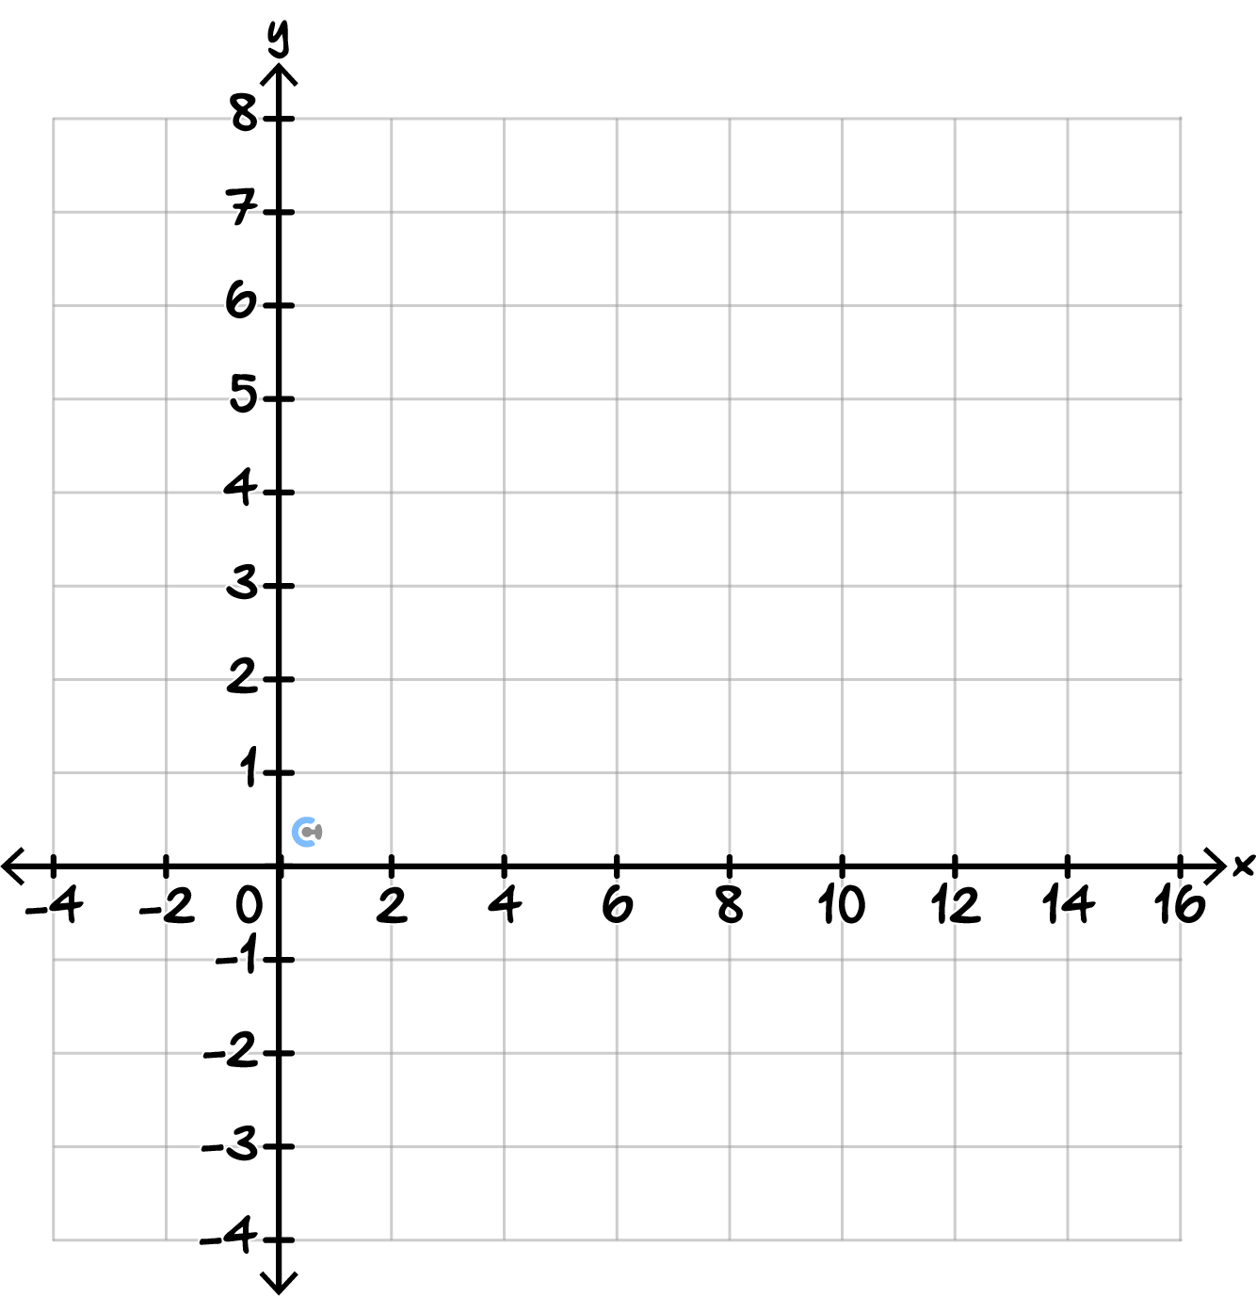

- (3 marks)

Consider the hyperbola:
$$y=\frac{7.5}{x-1.2}-2.5$$

  - State the equations of the asymptotes. (1 mark)
Solution:
Vertical asymptote: $x = 1.2$
Horizontal asymptote: $y = -2.5$

  - Determine the $x$-intercept, giving your answer correct to two decimal places. (1 mark)

At the x-intercept, $y = 0.$
$$0 =\frac{7.5}{x - 1.2}- 2.5$$
$$2.5 =\frac{7.5}{x - 1.2}$$
$$2.5\left(x - 1.2\right)= 7.5$$
$$x - 1.2 = 3$$
$$x = 4.2$$
$x$-intercept $= \left(4.20, 0\right)$

  - Determine the $y$-intercept, giving your answer correct to two decimal places. (1 mark)

Solution:
At the $y$-intercept, $x = 0.$
$$y =\frac{7.5}{0 - 1.2}- 2.5$$
$$y = -6.25 - 2.5$$
$$y = -8.75$$
$y$-intercept $= \left(0, -8.75\right)$

- (3 marks)

A circular pond is represented by:
$${\left(x-1.5\right)}^{2}+{\left(y+2.5\right)}^{2}=18.75$$

  - Determine the radius, giving your answer correct to two decimal places. (1 mark)
Solution:
$$r = \sqrt{18.75}$$
$$r ≈ 4.33$$
Radius $≈ 4.33$ units.

  - Determine the $x$-intercepts, giving your answers correct to two decimal places. (1 mark)
Solution:
At the $x$-intercepts,$y = 0.$
$${\left(x - 1.5\right)}^{2}+ {2.5}^{2}= 18.75$$
$${\left(x - 1.5\right)}^{2}= 12.5$$
$$x = 1.5 ± \sqrt{12.5}$$
$x ≈ -2.04$or$5.04$
$x$-intercepts $≈ \left(-2.04, 0\right)$ and $\left(5.04, 0\right)$

  - Sketch the circle, showing its centre and $x$-intercepts. (1 mark)
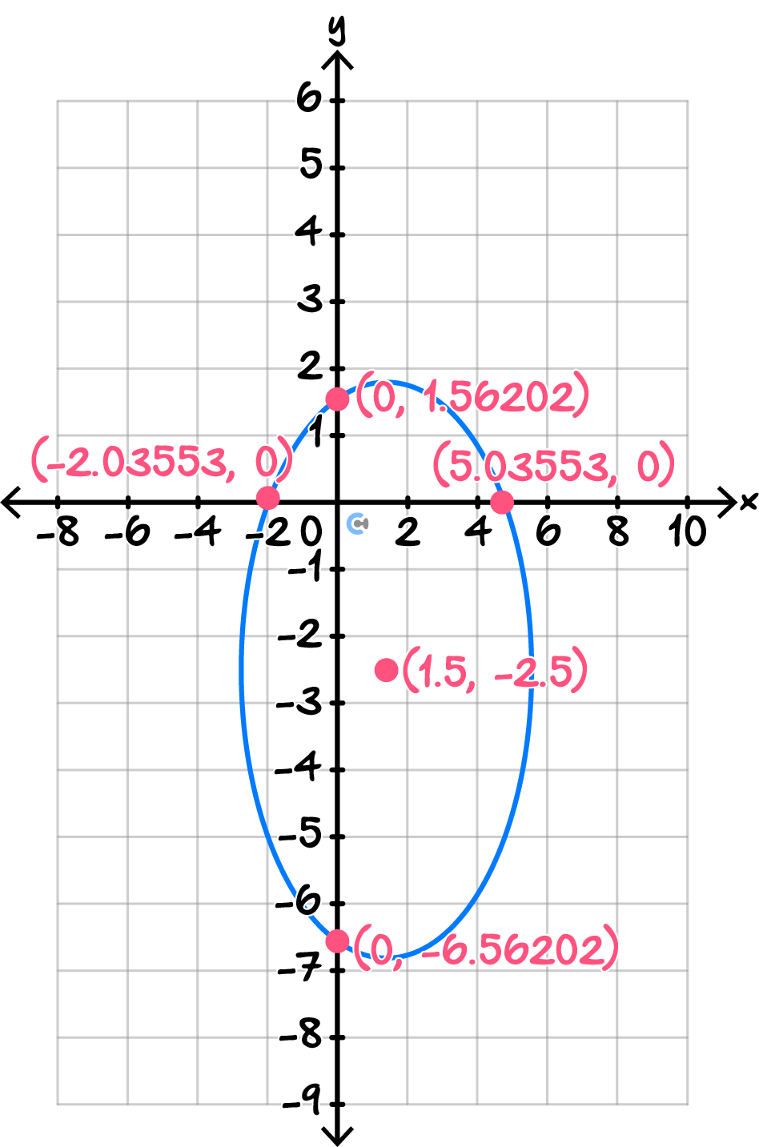
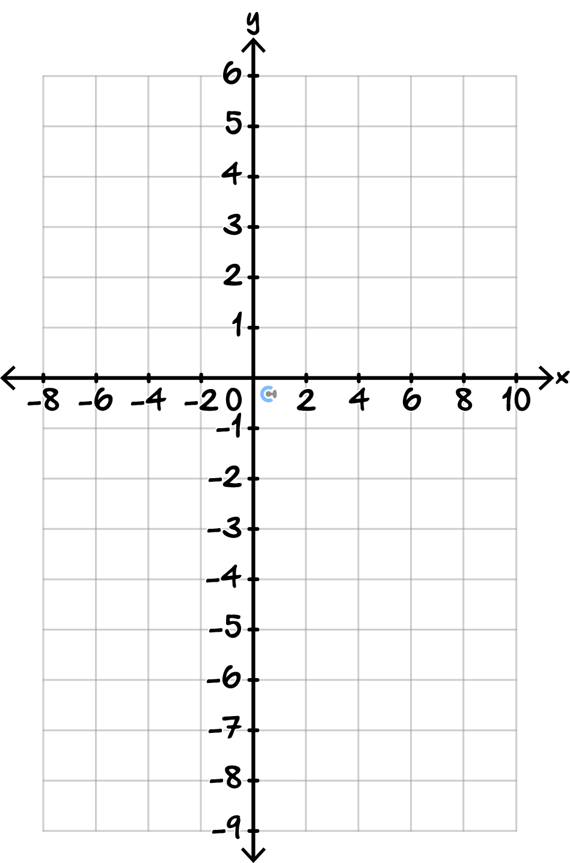

- (4 marks)

A circular safety zone is modelled by:

$${\left(x-2.5\right)}^{2}+{\left(y-1.5\right)}^{2}=20$$

A straight access path is modelled by:
$$y=0.8x-1.2$$

  - Find the two $x$-values at which the access path intersects the safety zone, giving your answers correct to two decimal places. (2 marks)

Solution:
Substitute $y = 0.8x - 1.2:$
$${\left(x - 2.5\right)}^{2}+ {\left(0.8x - 2.7\right)}^{2}= 20$$
Expanding:
$$x^{2}- 5x + 6.25 + 0.64x^{2}- 4.32x + 7.29 = 20$$
$$1.64x^{2}- 9.32x - 6.46 = 0$$
Solving:
$$s$$

  - Find the corresponding $y$-values, giving your answers correct to two decimal places. (2 marks)

Solution:
For $x ≈ -0.65:$
$$y = 0.8\left(-0.65\right)- 1.2$$
$$y ≈ -1.72$$
For $x ≈ 6.10:$
$$y = 0.8\left(6.10\right)- 1.2$$
$$y ≈ 3.68$$

Sub-Section: Even More Difficult

INSTRUCTION:

- Mastery: 12 Marks. 18 Minutes Writing.

- Extension: 12 Marks. 12 Minutes Writing.

- (4 marks)

A designer is modelling the profile of a curved entrance using:

$$y=-2\sqrt{x+3}+8$$

The designer wants to compare this with a second profile obtained from:

$$y=\sqrt{x}$$
by applying transformations.

  - Determine the $x$- and $y$-intercepts of the first profile, giving your answers correct to two decimal places.
(2 marks)
Solution:
For the $x$-intercept, set $y = 0:$
$$0 = -2\sqrt{x + 3}+ 8$$
$$2\sqrt{x + 3}= 8$$
$$\sqrt{x + 3}= 4$$
$$x + 3 = 16$$
$$x = 13$$
$x$-intercept $= \left(13.00, 0\right)$
For the y-intercept, set $x = 0:$
$$y = -2\sqrt{3}+ 8$$
$$y ≈ 4.54$$
$y$-intercept $≈ \left(0, 4.54\right)$

  - Describe the transformations required to obtain the first profile from $y=\sqrt{x}.$ (1 mark)

Solution:
- Reflection in the $x$-axis
- Vertical stretch by a factor of $2$
- Translation $3$ units to the left
- Translation $8$ units up

  - Sketch the graph and label the endpoint and both axes intercepts. (1 mark)
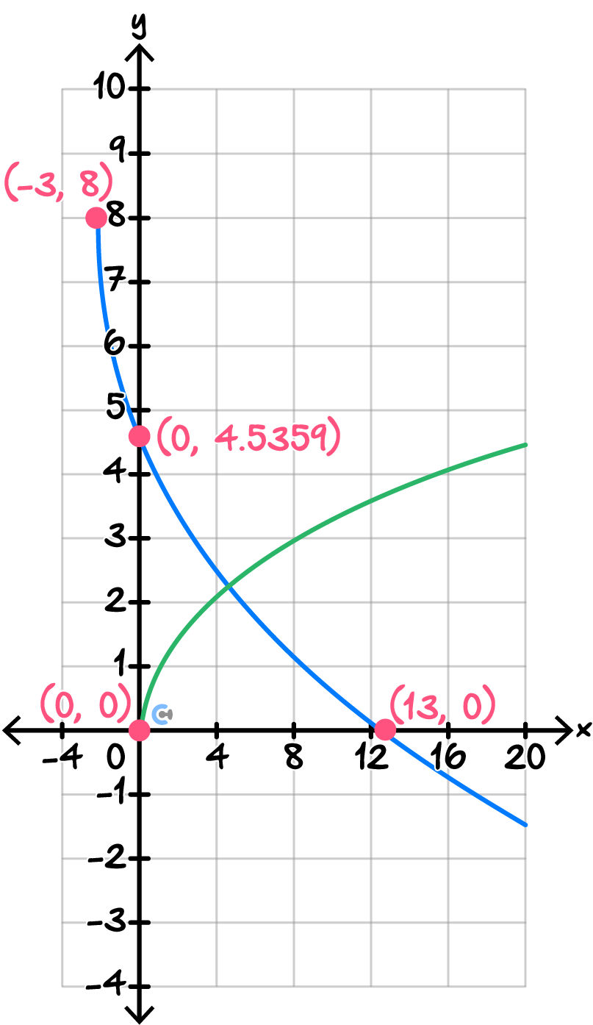
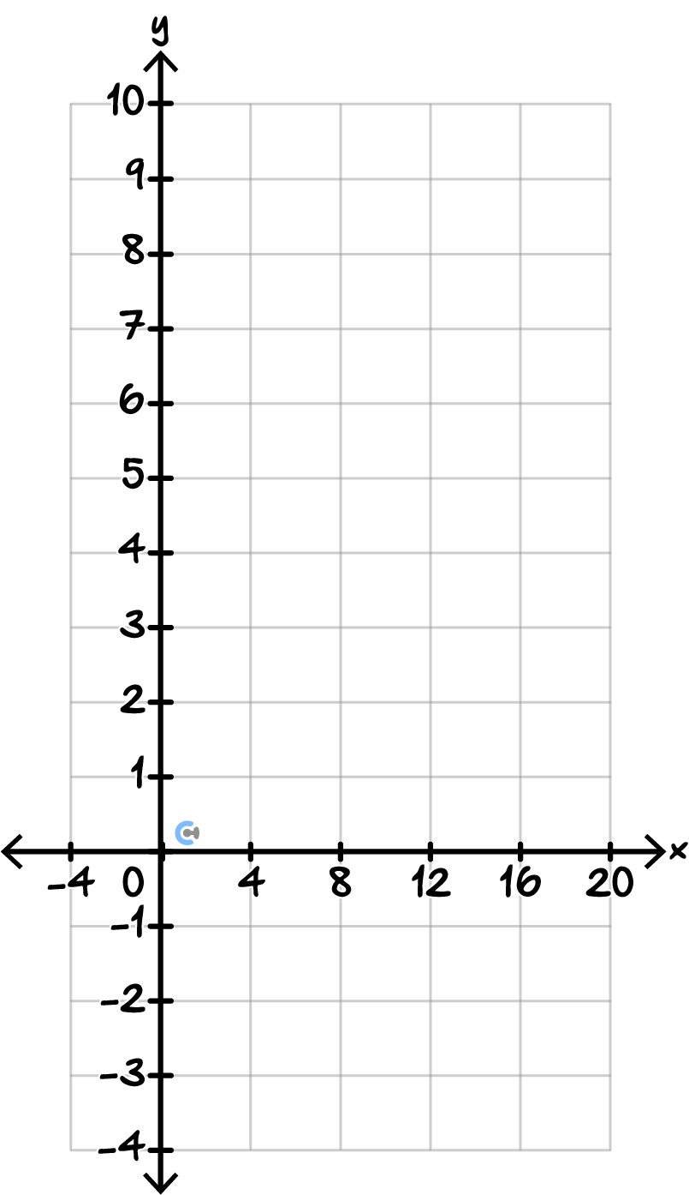

- (4 marks)

A monitoring system is modelled by the rectangular hyperbola:

$$y=-\frac{10}{x-2}+3$$

A technician claims that the point $\left(4, 0.5\right)$ lies on the graph.
Solution:
Substitute $x = 4:$
$$y = -\frac{10}{4 - 2}+ 3$$
$$y = -\frac{10}{2}+ 3$$
$$y = -5 + 3$$
$$y = -2$$
The point should have $y = -2$, not $0.5$.
Therefore, the claim is incorrect.
  - Determine whether the technician's claim is correct. (1 mark)

  - Determine the $x$-intercept and $y$-intercept of the hyperbola. (1 mark)
$x$-intercept $= \left(\frac{16}{3}, 0\right)$
$y$-intercept $= \left(0, 8\right)$

  - Sketch the hyperbola, labelling the asymptotes and both axes intercepts. (2 marks)
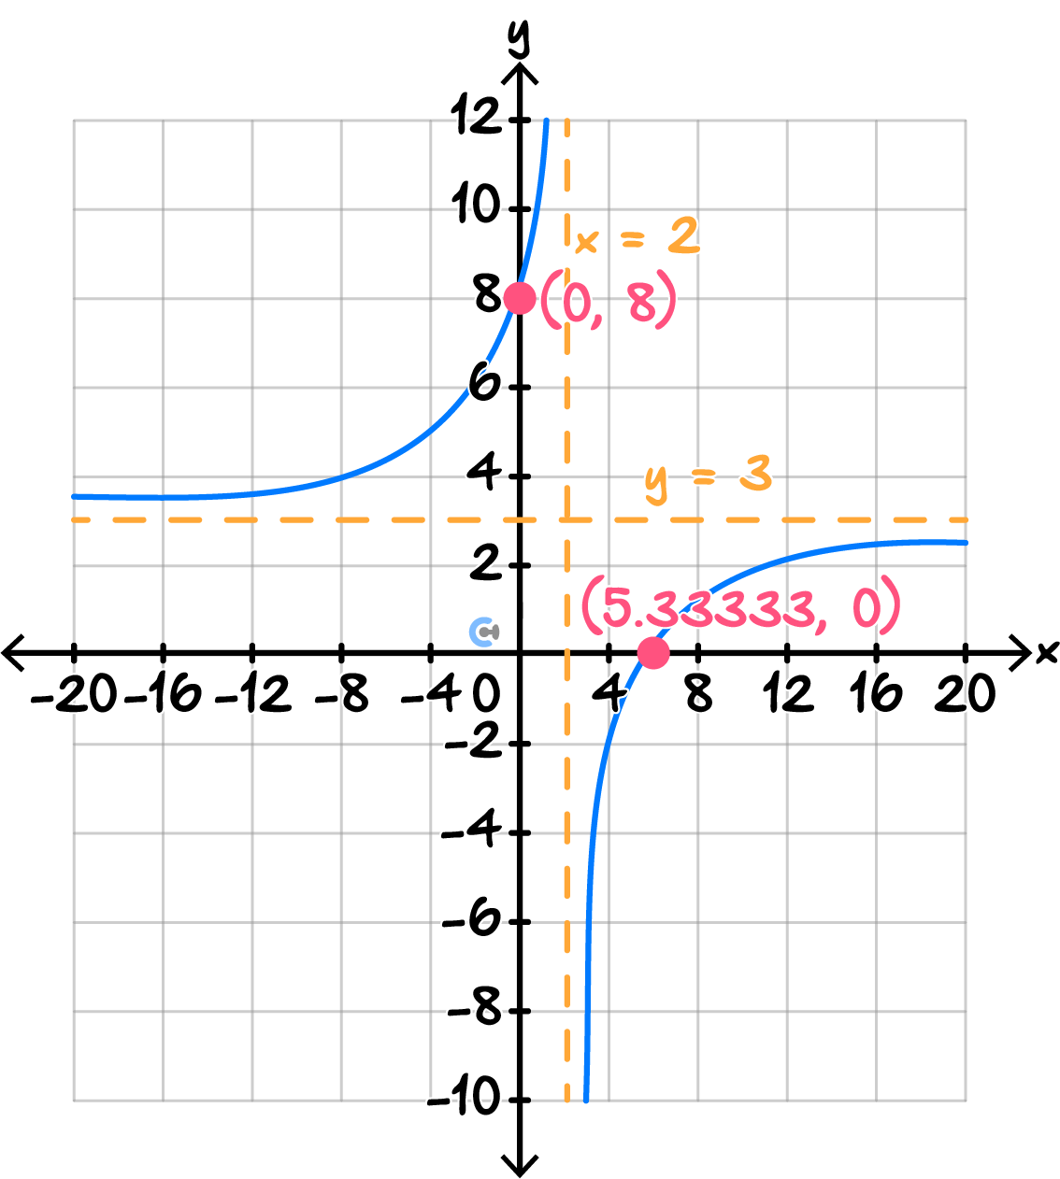
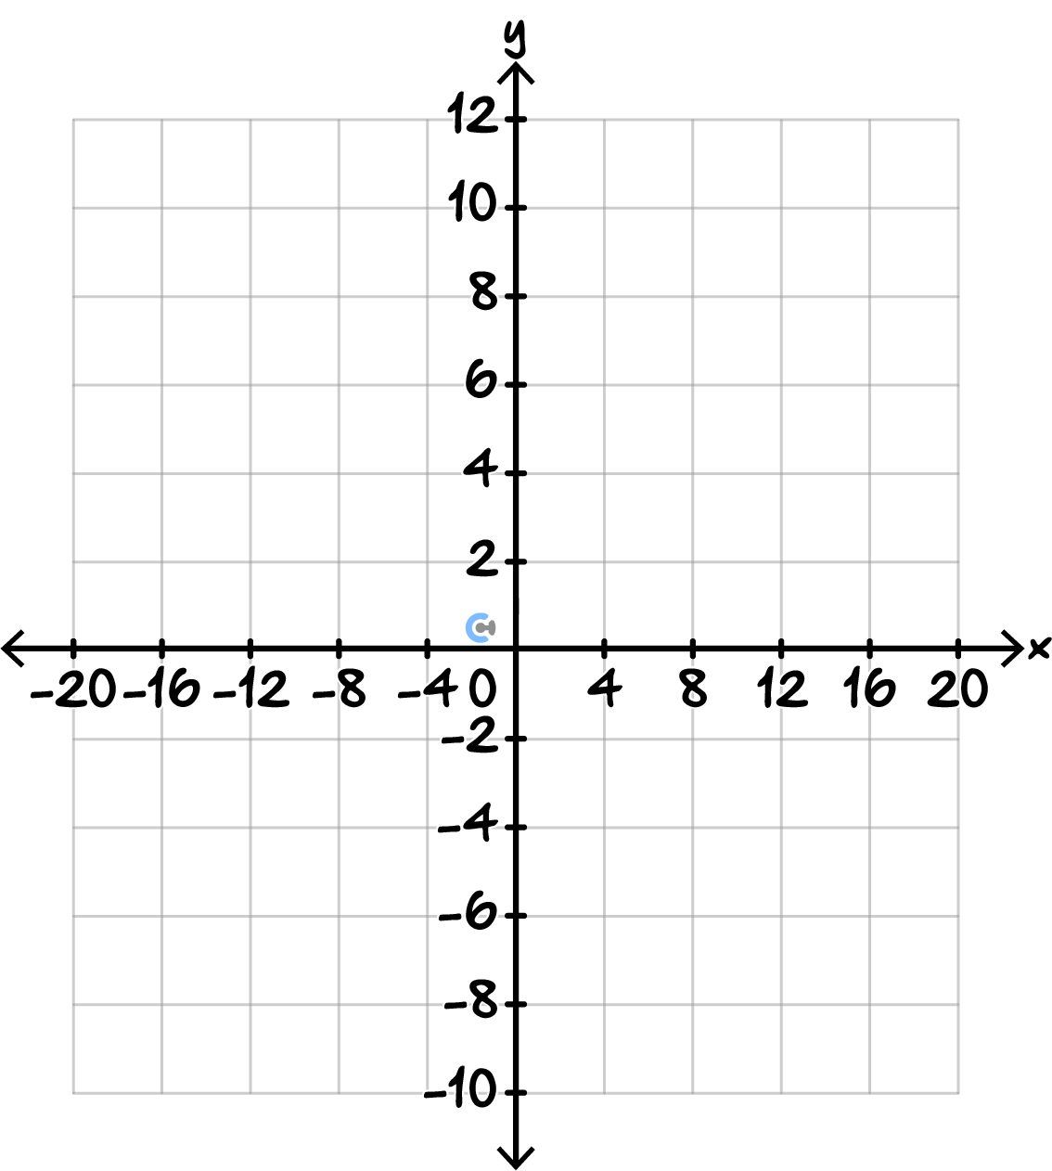

- (4 marks)

A circular exclusion zone is represented by:

$${\left(x-1\right)}^{2}+{\left(y+2\right)}^{2}=18$$

A proposed access path is represented by:

$$y=2x-4$$

  - Determine the two points where the path intersects the boundary of the exclusion zone, giving your answers correct to two decimal places. (2 marks)
Solution:
Substitute $y = 2x - 4:$
$${\left(x - 1\right)}^{2}+ {\left(2x - 4 + 2\right)}^{2}= 18$$
$${\left(x - 1\right)}^{2}+ {\left(2x - 2\right)}^{2}= 18$$
Expand:
$$x^{2}- 2x + 1 + 4x^{2}- 8x + 4 = 18$$
$$5x^{2}- 10x - 13 = 0$$
Using the quadratic formula:
$$x =\frac{\left[10 ± \sqrt{{\left(-10\right)}^{2}- 4\left(5\right)\left(-13\right)}\right]}{10}$$
$$x =\frac{\left[10 ± \sqrt{360}\right]}{10}$$
$x ≈ -0.90$or$2.90$

For $x ≈ -0.90:$
$$y = 2\left(-0.90\right)- 4$$
$$y ≈ -5.80$$
Point $≈ \left(-0.90, -5.80\right)$
For $x ≈ 2.90:$
$$y = 2\left(2.90\right)- 4$$
$$y ≈ 1.80$$
Point $≈ \left(2.90, 1.80\right)$

  - Determine whether a second path, $y = 2x + 1$, intersects the exclusion zone, touches it once, or does not meet it. (2 marks)
Solution:
Substitute $y = 2x + 1:$
$${\left(x - 1\right)}^{2}+ {\left(2x + 1 + 2\right)}^{2}= 18$$
$${\left(x - 1\right)}^{2}+ {\left(2x + 3\right)}^{2}= 18$$
Expand:
$$x^{2}- 2x + 1 + 4x^{2}+ 12x + 9 = 18$$
$$5x^{2}+ 10x - 8 = 0$$
Discriminant:
$$D = {10}^{2}- 4\left(5\right)\left(-8\right)$$
$$D = 100 + 160$$
$$D = 260$$
Since $D > 0$, the second path intersects the exclusion zone at two points.

Sub-Section: Extension

INSTRUCTION:

- Mastery: Skip.

- Extension: 16 Marks. 20 Minutes Writing.

- (5 marks)

A theme park uses a curved sensor profile to control the height of a safety barrier. The profile is modelled by:

$$y=-1.5\sqrt{x-1}+6$$

  - The safety barrier must meet the ground at its $x$-intercept. Determine the coordinates of this point. (1 mark)

Solution:
At the $x$-intercept, $y = 0.$
$$0 = -1.5\sqrt{x - 1}+ 6$$
$$1.5\sqrt{x - 1}= 6$$
$$\sqrt{x - 1}= 4$$
$$x - 1 = 16$$
$$x = 17$$
Therefore, the $x$-intercept is $\left(17, 0\right).$

  - The designer replaces the model with:

$$y=2\sqrt{x-3}-4$$Describe the transformations from $y=\sqrt{x}$ to the new model using the order of transformations. (2 marks)

Solution:

- Vertical stretch by a factor of $2$.
- Translation $3$ units to the right.
- Translation $4$ units down.

  - Sketch both profiles on the same axes, clearly showing the endpoint of each graph and the $x$-intercept of the original profile. (2 marks)
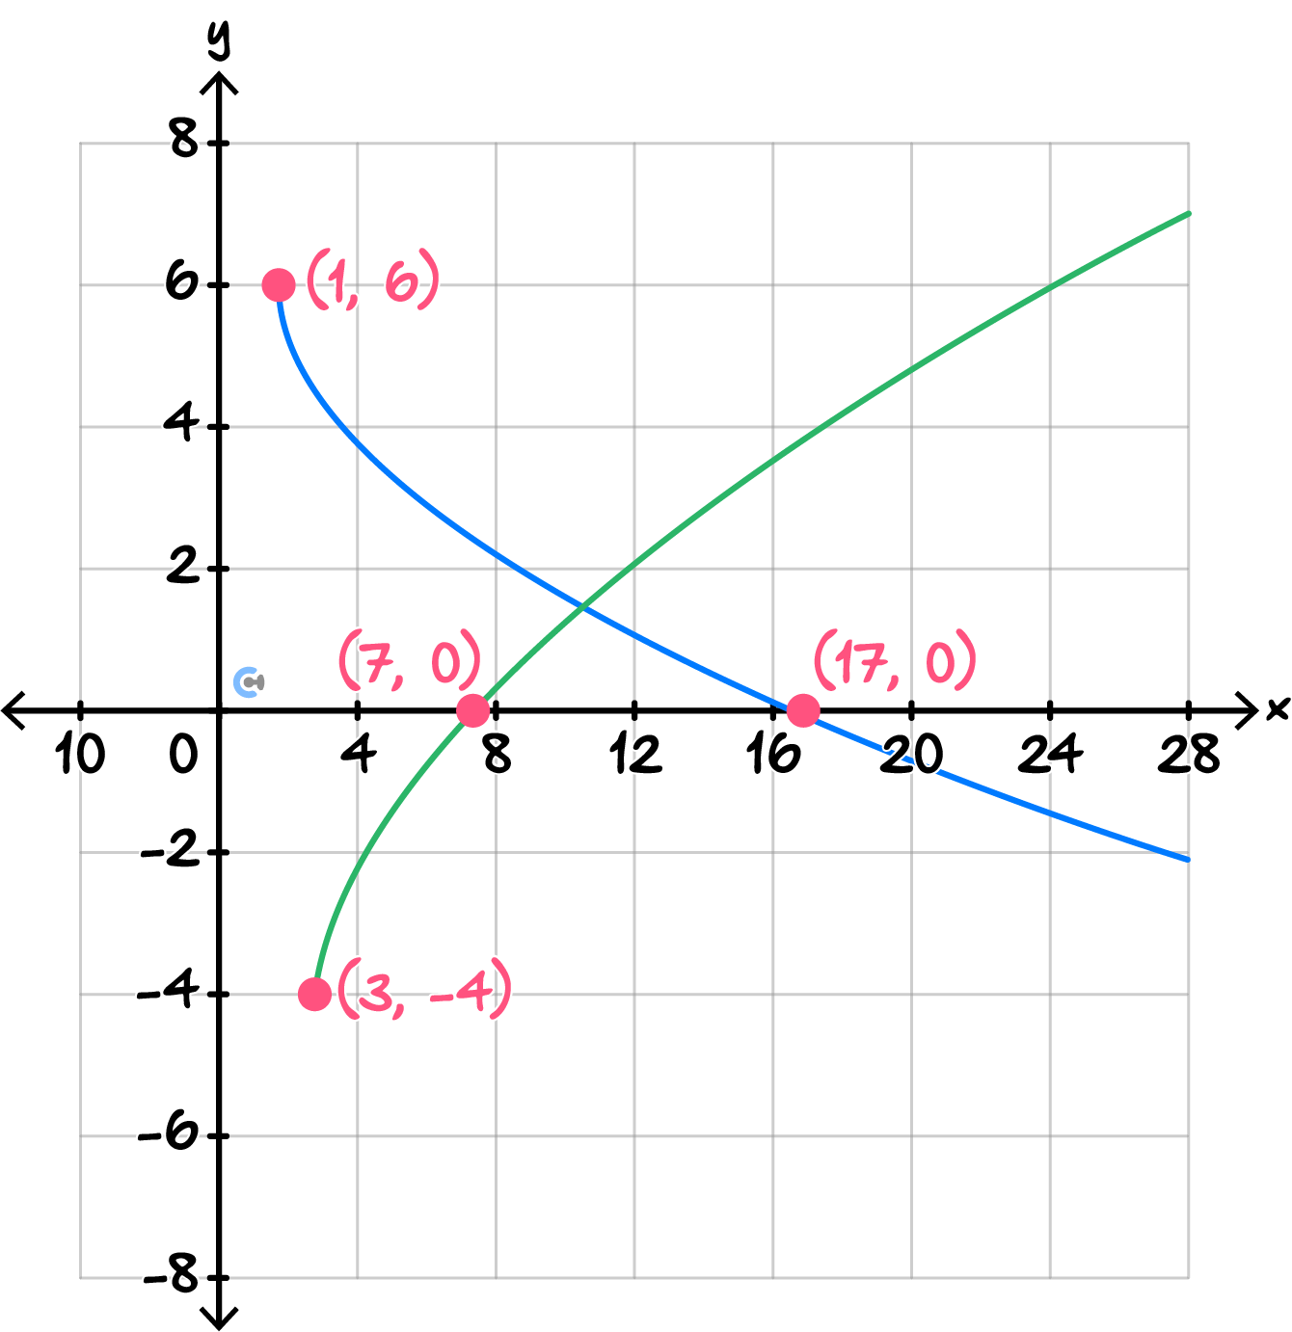
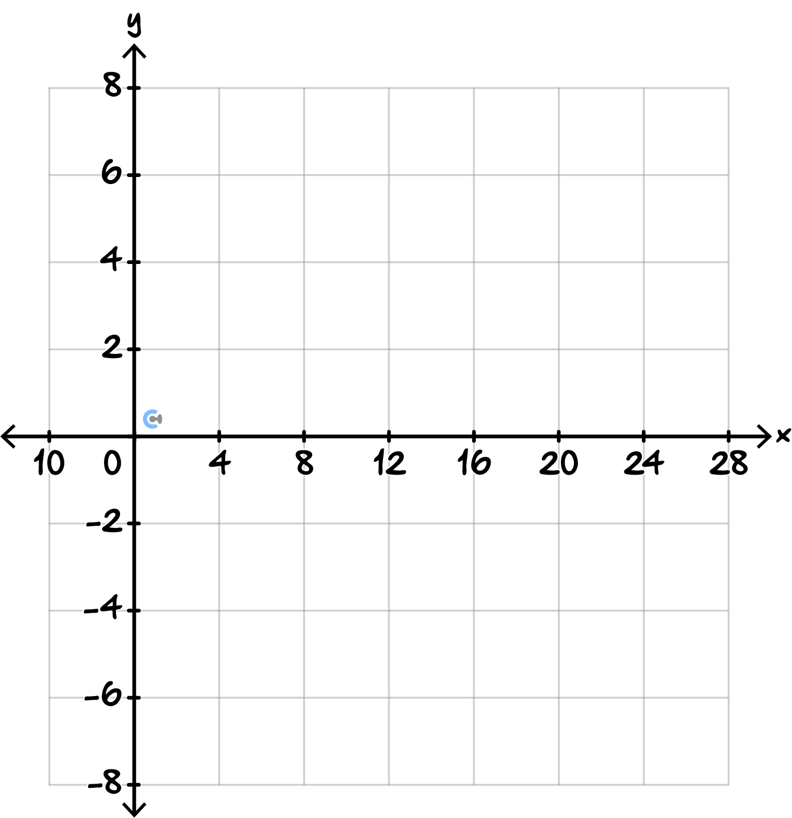

- (5 marks)

A rectangular ventilation opening is represented by the hyperbola:

$$y=\frac{9}{x-2}+1$$

An engineer changes the design so that the new opening is modelled by:

$$y=-\frac{9}{x+1}-3$$

  - State the equations of the asymptotes of the new opening. (1 mark)

Solution:
Vertical asymptote: $x = -1$
Horizontal asymptote: $y = -3$

  - Describe the transformations from $y=\frac{9}{x}$ to the new model. (2 marks)

Solution:

- Reflection in the $x$-axis.
- Translation$1$ unit to the left.
- Translation $3$ units down.

  - A circular inspection zone around the ventilation opening is modelled by:
$${\left(x+2\right)}^{2}+{\left(y+1\right)}^{2}=13$$Determine whether the horizontal asymptote from part a., intersects the circle. Use the discriminant to justify your answer. (2 marks)

Solution:
The horizontal asymptote is:
$$y = -3$$
Substitute $y = -3$ into the circle:
$${\left(x + 2\right)}^{2}+ {\left(-3 + 1\right)}^{2}= 13$$
$${\left(x + 2\right)}^{2}+ 4 = 13$$
$$x^{2}+ 4x - 5 = 0$$
Using the discriminant:
$$D = 4^{2}- 4\left(1\right)\left(-5\right)$$
$$D = 16 + 20$$
$$D = 36$$
Since $D > 0,$ there are two real solutions.
Therefore, the horizontal asymptote $y = -3$ intersects the circle at two points.
- (6 marks)

A circular drone-testing zone is modelled by:

$${\left(x-2\right)}^{2}+{\left(y+1\right)}^{2}=13$$

A flight path is modelled by:

$$y=0.75x-2.5$$

  - Determine the points where the flight path enters and leaves the circular zone, giving your answers correct to two decimal places. (2 marks)

Solution:
Substitute $y = 0.75x - 2.5:$
$${\left(x - 2\right)}^{2}+ {\left(0.75x - 3.5\right)}^{2}= 13$$
Expand:
$$x^{2}- 4x + 4 + 0.5625x^{2}- 5.25x + 12.25 = 13$$
$$1.5625x^{2}- 9.25x + 3.25 = 0$$
Using the quadratic formula:
$x ≈ 0.37$or$5.55$
For $x ≈ 0.37:$
$$y = 0.75\left(0.37\right)- 2.5$$
$$y ≈ -2.22$$
Point $≈ \left(0.37, -2.22\right)$
For $x ≈ 5.55:$
$$y = 0.75\left(5.55\right)- 2.5$$
$$y ≈ 1.66$$
Point $≈ \left(5.55, 1.66\right)$

  - A second flight path is modelled by:
$$y=-x+4$$Determine whether this path intersects the circular zone at two points, touches it at one point, or does not intersect it. (2 marks)
Solution:
Substitute $y = -x + 4:$
$${\left(x - 2\right)}^{2}+ {\left(-x + 4 + 1\right)}^{2}= 13$$
$${\left(x - 2\right)}^{2}+ {\left(-x + 5\right)}^{2}= 13$$
$$x^{2}- 4x + 4 + x^{2}- 10x + 25 = 13$$
$$2x^{2}- 14x + 16 = 0$$
$$x^{2}- 7x + 8 = 0$$
Discriminant: $D = {\left(-7\right)}^{2}- 4\left(1\right)\left(8\right)= 49 - 32$ $= 17$
Since $D > 0$, the second path intersects the circular zone at two points.

  - Sketch the circular zone and both flight paths on the same axes, labelling the two intersection points of the first path and indicating the position of the second path. (2 marks)

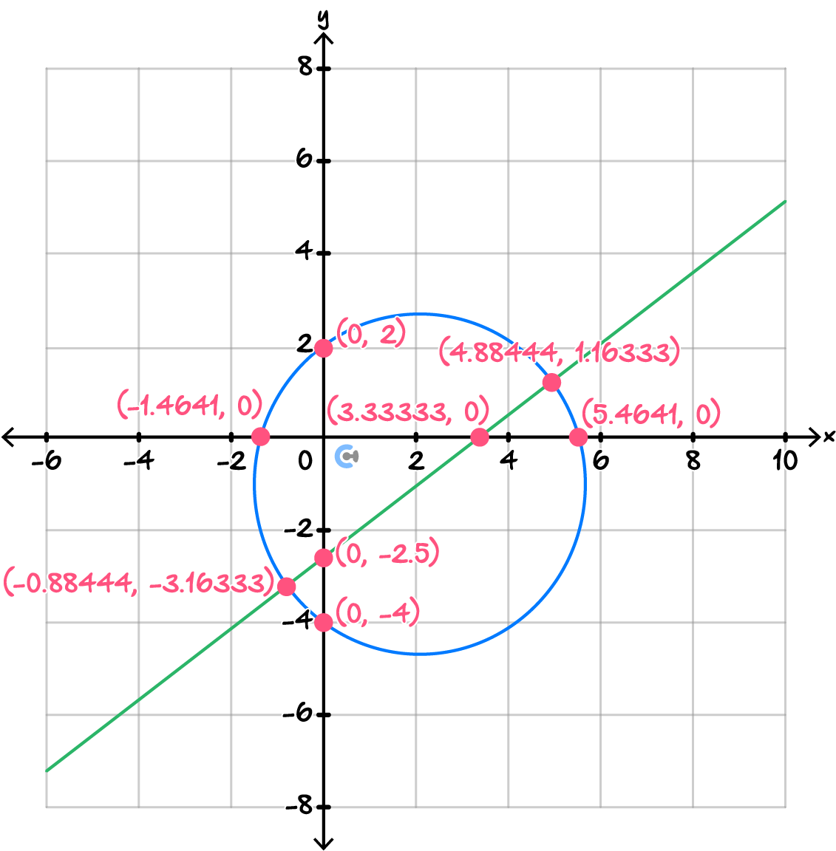
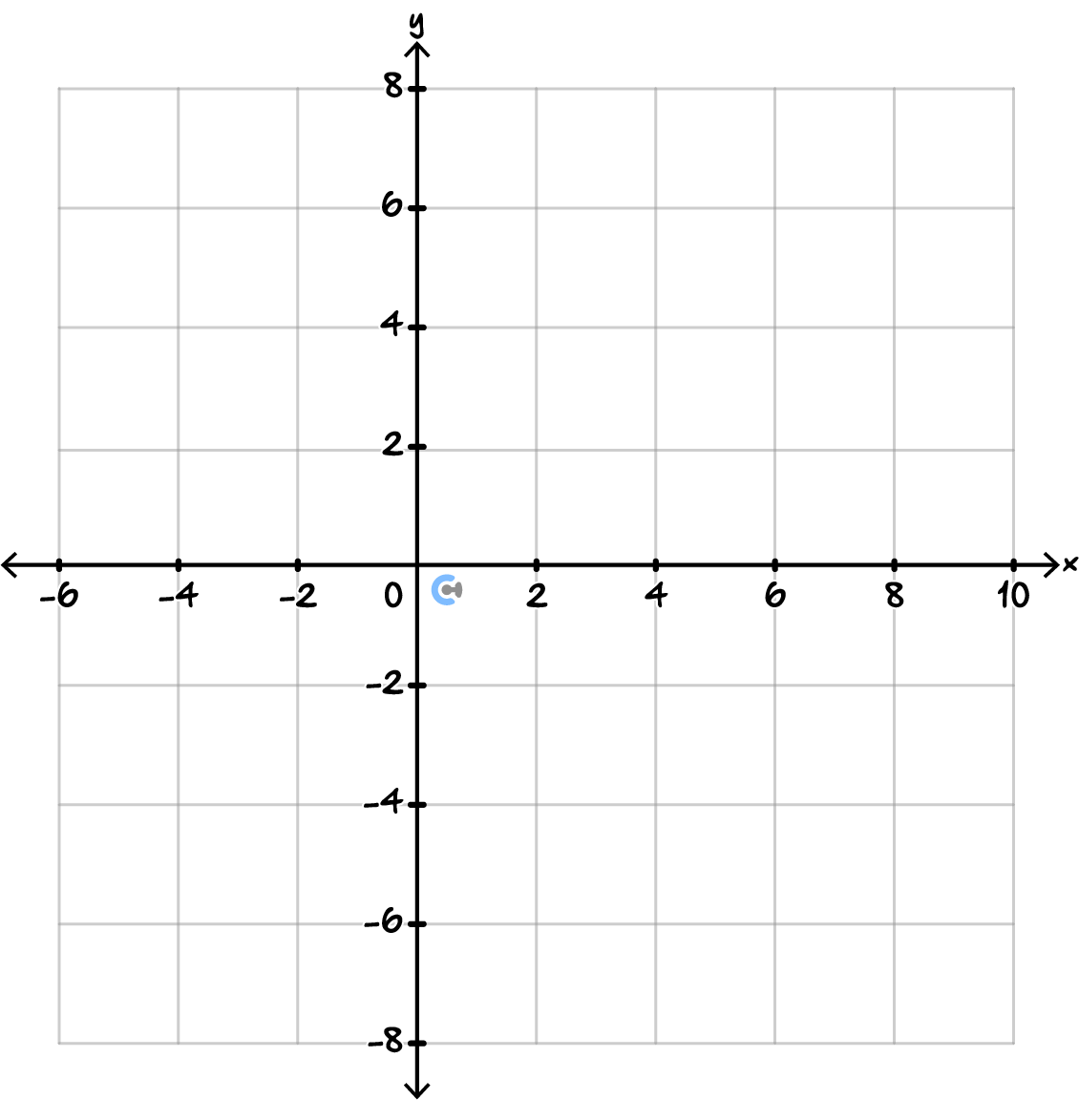

Space for Personal Notes

Space for Personal Notes

Space for Personal Notes





